Running to a standstill: How responsive have successive ONS life expectancy forecasts been to stalling life expectancy gains since 2010?

Abstract

## **Background**

The UK Office for National Statistics (ONS) updates their life expectancy forecasts every two years. During much of the 2000s these forecasts tended to underestimate life expectancy improvement, and were successively uprated, but since 2010 they have tended to underestimate life expectancy improvement, and have been successively downrated. The most recent 2018 forecast was released in 2019. This paper asks whether the assumptions in this most recent forecast is still too optimistic given recent life expectancy improvement rates in the UK have still been very modest.

**Methods**

Period life expectancy at birth (e­­0) was extracted from the Human Mortality Database (HMD) to allow comparison between the UK and other high income nations, and from the ONS to allow comparison within UK nations and groups. Annual change in life expectancy across European and Anglophone nations was calculated to assess the extent to which a slowdown in e0 improvement rates is seen internationally, and within UK nations to assess how similar trends in slowdown are within the UK. For UK nations changepoint analysis is performed to assess whether the slowdown is contemporaneous, suggesting common exposure. ONS forecasts from 2012 onwards for the UK as a whole are shown to demonstrate the extent of the slowdown assumed by each biennial projection, including as heatmaps showing changes in conditional life expectancy between successive projections.

To better determine the amount of annual gain in e0 that should be assumed if current e0 improvement rates were to continue, 101 different e0 gain scenarios, ranging from 0% slowdown, assuming no slowdown since the breakpoint year, to 100% slowdown, assuming no gain since the breakpoint year, and the Bayes Factor (ratio of likelihoods) for each of these scenarios calculated as compared with the 0% slowdown scenario. The scenario that maximises the Bayes Factor is identified. Each ONS biennial projection is converted into an improvement rate scenario, and the Bayes Factor for each of these scenarios calculated as well.

## **Results**

Slowdowns in e0 gain have been observed in a number of high income nations in recent years, but have been more severe in the UK than in all other nations except USA. In all UK nations except Northern Ireland, a breakpoint in improvement rates between 2010 to 2011 was identified. Between 2010 and 2012 ONS life expectancy forecasts were reduced first for females, then for both genders. If average rates of e0 gain since 2010 were to continue then the assumption that life expectancy improvement rates have slowed down by xx% is most likely (Bayes Factor: XX cf no slowdown). This compares with an implied slowdown of xx% for the 2018 ONS life expectancy projection (Bayes Factor: XX cf no slowdown).

**Discussion**  
The most recent ONS life expectancy forecast still appears to be too optimistic, and to underestimate the extent of the slowdown seen in the UK since 2010. Without clear agreement as to the cause of the slowdown, which is more severe than almost any other high income nation, no consistent action is being taken that should cause us to believe that the problems facing UK populations have been addressed, and so there is no good reason to believe that the stalling in e0 gains observed since 2010 will not continue. The Bayes Factor strategy used here can be used to update our beliefs about how life expectancy trends are likely to continue whenever a new observation becomes available, and the addition of observed life expectancies for 2018 added weight to belief that life expectancy improvement rates have, since 2010, slowed to around a fifth their previous levels.

**Introduction**

Every couple of years, the UK’s ONS produces new population projections, including new assumptions about mortality and longevity. Such projections, whether carried out by national statistical bodies or by private insurers, are vital inputs to a wide range of important decisions for the effective provision of state services and assets, including schools, social and healthcare needs at UK, national and local levels.

Up until 2010, ONS forecasts of life expectancy gains consistently underestimated rates of improvement, and the assumptions were consistently uprated and made more optimistic in successive revisions.(1) However, since 2010 the life expectancy improvement assumptions made by the ONS have been too optimistic, and now been successively made more pessimistic for the fourth revision in a row.

In parallel with the ONS’ attempts to accurately project and predict life expectancy trends, academic demographers and commercial actuaries working for the life insurance and financial industries have also been making predictions.

A number of different approaches to forecasting life expectancy have been tried. The most technically sophisticated approaches have involved forecasting the individual components of life expectancy, mortality rates at individual ages, and calculating life expectancies based on estimated lifetables, (2) made use of Bayesian methods for ‘smoothing’ observations from neighbouring years and age groups, (3,4), and/or incorporating cohort effects in improvement rates which allow for faster or slower gains in some cohorts than others. (5) An important example of this, which when identified by commercial actuaries led to substantial increases in projected life expectancies, was the identification of a so-called ‘Golden Cohort’ in the UK, persons born between around 1925 and 1945, whose rates of mortality improvement appeared systematically higher than for earlier or later cohorts. (6) Though cohort effects had been identified many decades previously, (7) they had often been deleterious rather than positive (8,9), and the UK’s cohort effect was of particular interest to the actuarial profession as they constituted a source of substantial ‘longevity risk’ affecting the viability of both private and state pensions. (10)

Perhaps surprisingly, more complex approaches to demographic forecasting have not been found to outperform simpler approaches, (11), and a very simple approach to forecasting life expectancy, which does not involve forecasting mortality at individual ages, has also been found to be effective. (12) This approach simply involves assuming that life expectancy improvements will tend to continue to improve linearly on average over the long term. This assumption seems to hold more for the average of many similar populations, or for the best performing of a collection of high income nations, (13–15) than for any single population, but has the dual advantages of simplicity, and of allowing uncertainty intervals in projections to be generated using the observed variation in annual changes in life expectancy using well-established time series modelling strategies. (16) This will be the main approach taken in this paper.

Since around 2014, worsening trends in life expectancy improvement have been an increasing area of focus and concern in the UK amongst public health researchers and academics. (17–22) Much of the analysis and commentary surrounding the slowing improvement rates in life expectancy has focused on the role of UK-government austerity policies, and corresponding changes in funding and provision of out-of-work benefits, social and healthcare funding (23–25), continuing concerns raised previously about the adverse health effects of austerity in an international context. (26–28) Analyses conducted and commissioned by Public Health England, The Kings Fund, the Health Foundation, and the OECD have instead focused more on extensive description of trends broken down into disease categories, emphasised the multifactorial nature of the slowdown, and the role of influenza (in 2013-14) and slowing cardiovascular disease improvements in particular. (29–33)

This paper aims to bring some of these divergent strands of researchers together by focusing on the way ONS mortality projections have changed over this period of stalling UK life expectancy, and how new data about UK life expectancies can be better used to inform our assumptions about future life expectancy trajectories in the UK. We introduce a complementary approach to both evaluating and updating beliefs about how substantial and persistent the recent stalling in life expectancy improvements have been, which uses Bayes Factors to estimate the relative likelihood of having observed the life expectancy improvement that have been observed since 2010 if the long-term trends in life expectancy improvement rates previously observed were still continuing. The approach allows quick updating of beliefs about how far short post-2010 improvement rates have fallen from earlier trends, which can rapidly incorporate each new annual release of UK life expectancy data. This means we can produce interim life expectancy projections in the years between the biennial releases.

Though the paper does not aim to resolve disagreement between researchers as to the causes of the recent slowdown, it does aim to make the process of reasoning about the extent and persistence of the post 2010 slowdown more explicit, along with the process of updating our beliefs about the extent of this slowdown as and when new annual life expectancy estimates become available. To the extent the approach can be used to formally quantify and assess divergence between the UK’s life expectancy gains and those in other high income countries, and to demonstrate that slowdown has continued to persist longer than would be expected if it were due to transient factors like ‘bad winters’, the paper does aim to advance causal thinking about the slowdown indirectly, through establishing commonly acceptable strategies for analysis and interpretation of UK life expectancy data, and ‘ground truths’ around which researchers with divergent beliefs and perspectives can agree.

The rest of this paper proceeds as follows: Firstly, we will present annual change rates in life expectancy in the UK as compared with a number of other high income countries, to determine the extent to which the recent slowdown in life expectancy in the UK is an international phenomenon. Secondly, we will calculate changes in life expectancy for each UK nation or group of nations, to see whether the slowdown is similar in magnitude and contemporaneous throughout UK populations; this will be supported by performing change-point analysis of annual life expectancy changes for each of these UK populations. Thirdly, we will present the ONS life expectancy projections for the UK from 2012 onwards, to show how these projections have been successively downrated with each biennial projection. Fourthly, we will formally quantify the extent of the slowing in life expectancy improvement rates since 2010 by proposing a series of 100 modelled scenarios, each corresponding to a different percentage slowdown from earlier trends, and identifying the slowdown rate that maximises the Bayes Factor (ratio of model likelihoods, as compared with no slowdown) given observed life expectancy. Finally, we will estimate the Bayes Factors implied by each of the average improvement rates implied by each of the recent ONS mortality projections, discussing how optimistic or pessimistic each of these scenarios seems to be, and how the Bayes Factor strategy can be applied to more openly update our beliefs about the persistence and extent of a life expectancy slowdown in the UK as and when the 2019 period life expectancy estimate becomes available.

# Methods

The Human Mortality Database (HMD) is a joint initiative by the Max Planck Institute for Demographic, the University of California, and INED in Paris, which aims to provide detailed mortality and population data for research, including life expectancy estimates produced using a standard set of methods for many different populations. It currently covers 41 countries or areas

Period life expectancy at birth (e­­0) was extracted from the Human Mortality Database (HMD) to allow comparison between the UK and other high income nations, and from the ONS to allow comparison within UK nations and groups. Annual change in life expectancy across European and Anglophone nations was calculated to assess the extent to which a slowdown in e0 improvement rates is seen internationally, and within UK nations to assess how similar trends in slowdown are within the UK. For UK nations changepoint analysis is performed to assess whether the slowdown is contemporaneous, suggesting common exposure. ONS forecasts from 2012 onwards for the UK as a whole are shown to demonstrate the extent of the slowdown assumed by each biennial projection, including as heatmaps showing changes in conditional life expectancy between successive projections.

To better determine the amount of annual gain in e0 that should be assumed if current e0 improvement rates were to continue, 101 different e0 gain scenarios, ranging from 0% slowdown, assuming no slowdown since the breakpoint year, to 100% slowdown, assuming no gain since the breakpoint year, and the Bayes Factor (ratio of likelihoods) for each of these scenarios calculated as compared with the 0% slowdown scenario. The scenario that maximises the Bayes Factor is identified. Each ONS biennial projection is converted into an improvement rate scenario, and the Bayes Factor for each of these scenarios calculated as well.

Results

## Change in life expectancy, UK compared with other high income nations

Firstly, we will present annual change rates in life expectancy in the UK as compared with a number of other high income countries, to determine the extent to which the recent slowdown in life expectancy in the UK is an international phenomenon.

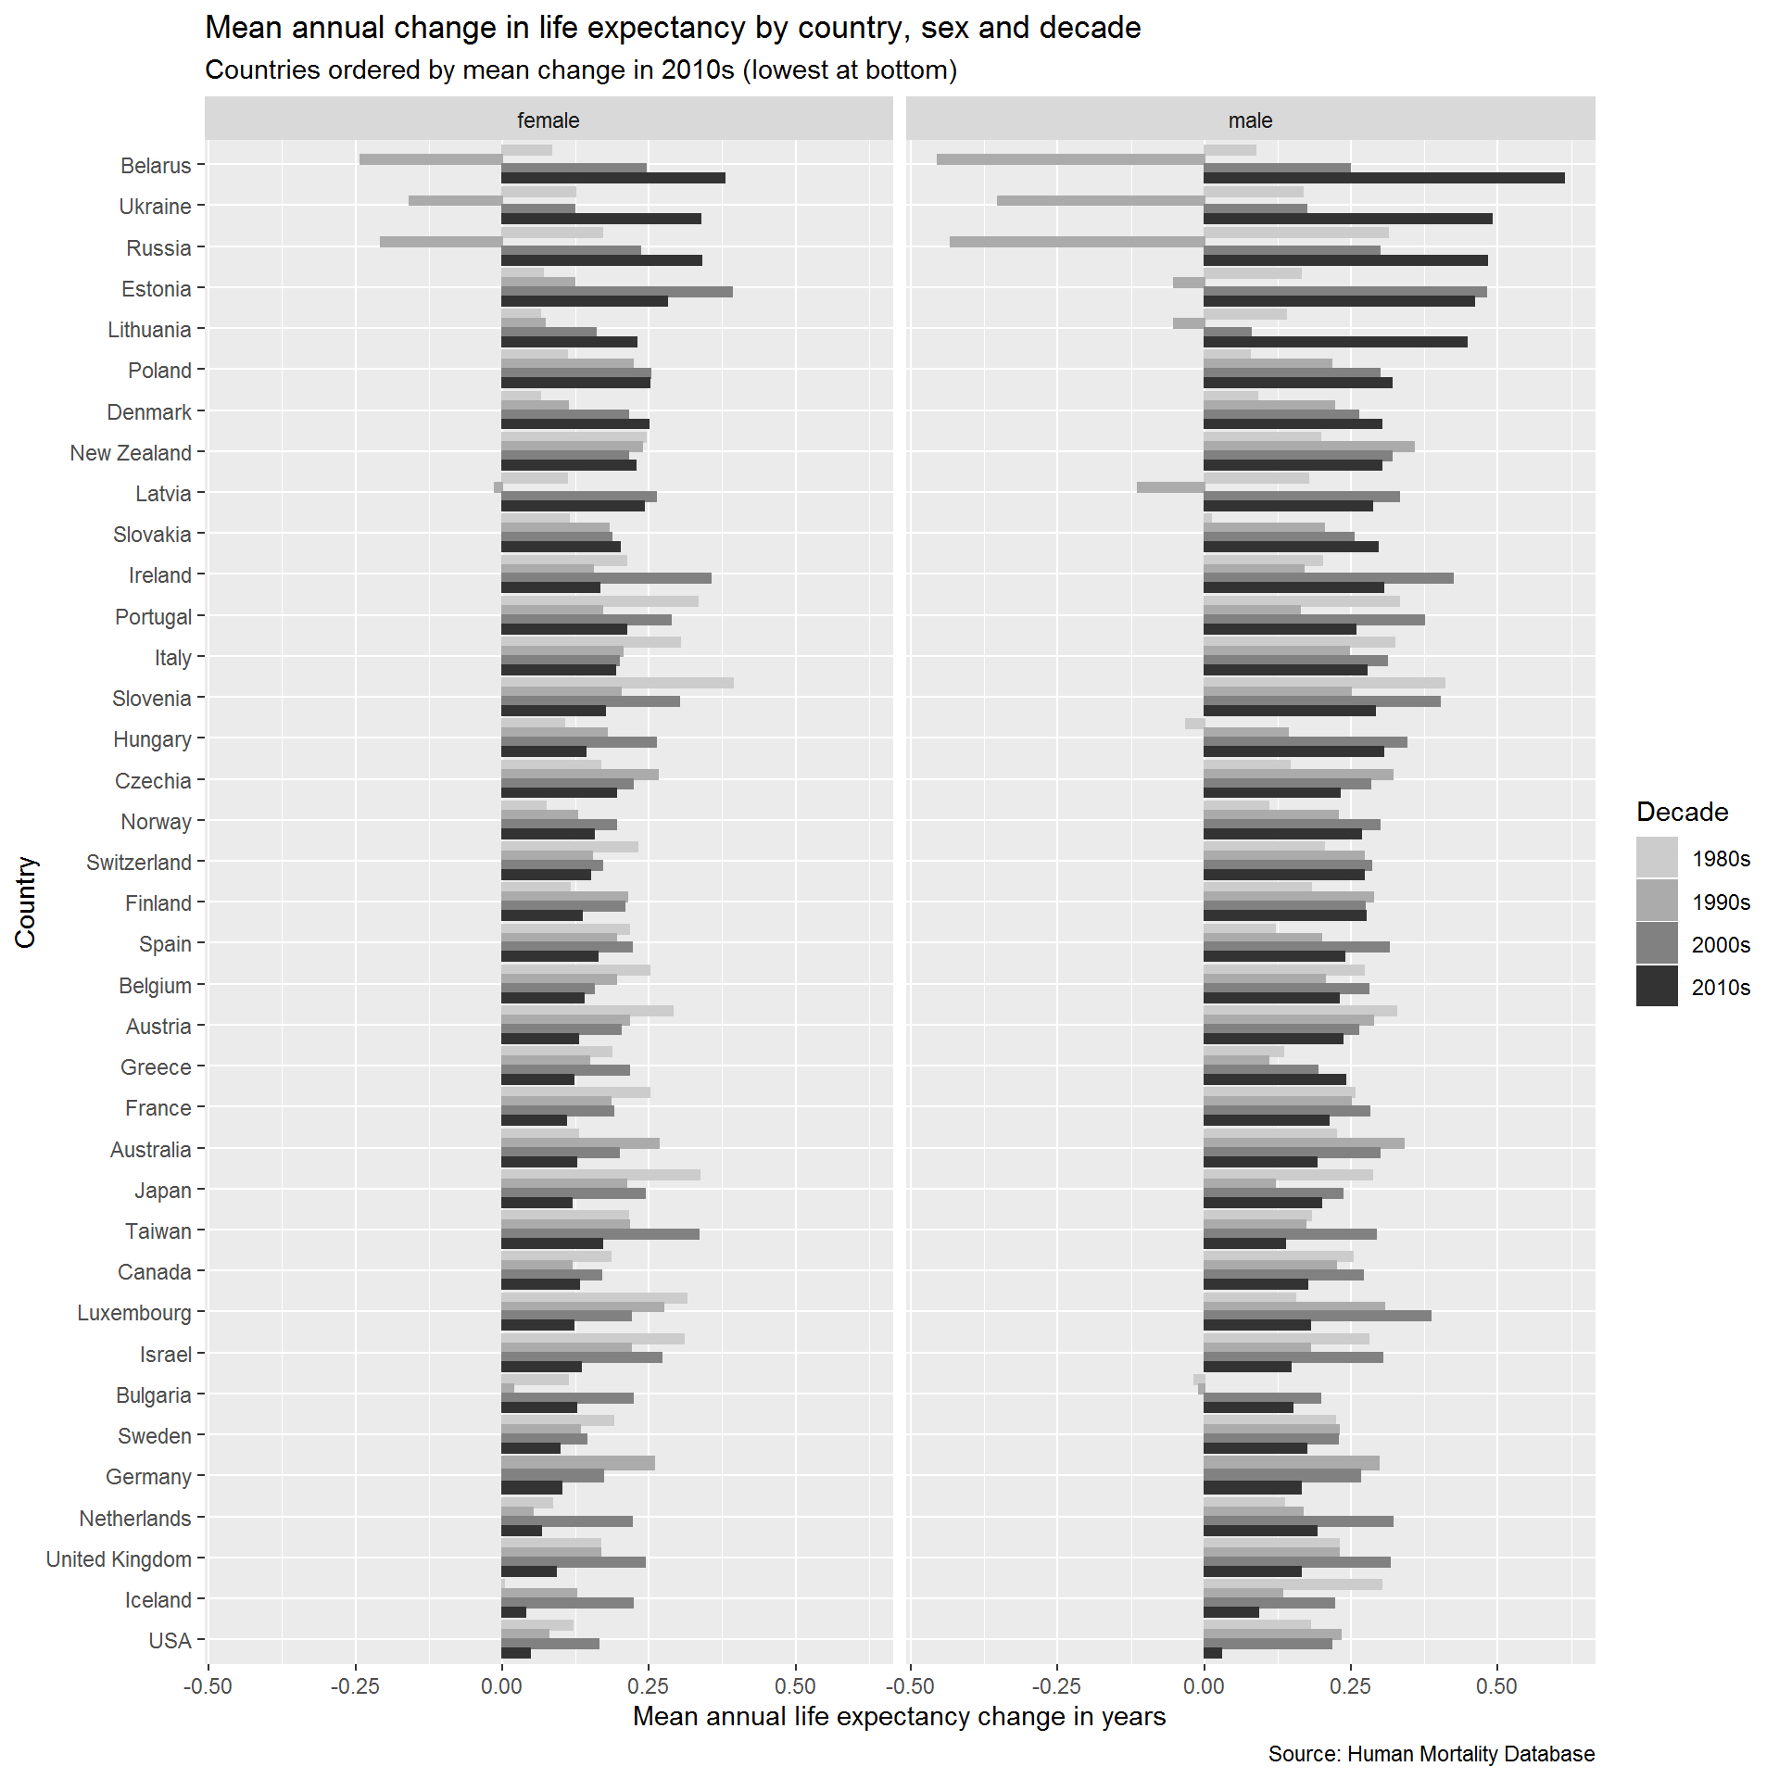

**1.2.1 HMD Average change in e0 by decade**

**1.2.1.1 Figure of HMD Average change in e0 by decade**

**1.2.1.2 Table of HMD Average change in e0e0 by decade**

|  | **Female** | | | | **Male** | | | |
| --- | --- | --- | --- | --- | --- | --- | --- | --- |
| **Country** | **1980s** | **1990s** | **2000s** | **2010s** | **1980s** | **1990s** | **2000s** | **2010s** |
| Australia | 0.129 | 0.267 | 0.199 | 0.127 | 0.224 | 0.339 | 0.299 | 0.191 |
| Austria | 0.291 | 0.217 | 0.202 | 0.130 | 0.328 | 0.288 | 0.262 | 0.235 |
| Belarus | 0.083 | -0.242 | 0.245 | 0.379 | 0.087 | -0.454 | 0.248 | 0.613 |
| Belgium | 0.251 | 0.195 | 0.157 | 0.139 | 0.272 | 0.205 | 0.279 | 0.229 |
| Bulgaria | 0.112 | 0.019 | 0.223 | 0.126 | -0.018 | -0.009 | 0.197 | 0.150 |
| Canada | 0.186 | 0.118 | 0.169 | 0.131 | 0.252 | 0.225 | 0.270 | 0.176 |
| Czechia | 0.168 | 0.265 | 0.222 | 0.195 | 0.146 | 0.321 | 0.283 | 0.231 |
| Denmark | 0.064 | 0.113 | 0.215 | 0.250 | 0.090 | 0.222 | 0.263 | 0.301 |
| Estonia | 0.069 | 0.123 | 0.392 | 0.281 | 0.164 | -0.052 | 0.481 | 0.460 |
| Finland | 0.116 | 0.213 | 0.208 | 0.136 | 0.181 | 0.287 | 0.274 | 0.274 |
| France | 0.251 | 0.185 | 0.190 | 0.109 | 0.256 | 0.249 | 0.281 | 0.211 |
| Germany | NA | 0.259 | 0.173 | 0.101 | NA | 0.297 | 0.266 | 0.165 |
| Greece | 0.186 | 0.149 | 0.216 | 0.122 | 0.135 | 0.109 | 0.193 | 0.240 |
| Hungary | 0.107 | 0.178 | 0.263 | 0.143 | -0.031 | 0.143 | 0.345 | 0.305 |
| Iceland | 0.003 | 0.127 | 0.223 | 0.040 | 0.302 | 0.133 | 0.222 | 0.091 |
| Ireland | 0.212 | 0.155 | 0.355 | 0.166 | 0.201 | 0.169 | 0.423 | 0.305 |
| Israel | 0.310 | 0.220 | 0.272 | 0.134 | 0.280 | 0.181 | 0.303 | 0.147 |
| Italy | 0.303 | 0.205 | 0.199 | 0.192 | 0.324 | 0.247 | 0.311 | 0.276 |
| Japan | 0.337 | 0.212 | 0.244 | 0.119 | 0.286 | 0.121 | 0.236 | 0.199 |
| Latvia | 0.111 | -0.013 | 0.263 | 0.242 | 0.177 | -0.114 | 0.332 | 0.286 |
| Lithuania | 0.064 | 0.073 | 0.160 | 0.229 | 0.140 | -0.051 | 0.079 | 0.447 |
| Luxembourg | 0.314 | 0.275 | 0.220 | 0.123 | 0.154 | 0.306 | 0.386 | 0.180 |
| Netherlands | 0.086 | 0.053 | 0.221 | 0.067 | 0.136 | 0.167 | 0.321 | 0.191 |
| New Zealand | 0.244 | 0.238 | 0.215 | 0.228 | 0.198 | 0.357 | 0.320 | 0.302 |
| Norway | 0.074 | 0.128 | 0.194 | 0.157 | 0.110 | 0.228 | 0.298 | 0.268 |
| Poland | 0.110 | 0.223 | 0.253 | 0.251 | 0.078 | 0.217 | 0.298 | 0.319 |
| Portugal | 0.333 | 0.171 | 0.288 | 0.212 | 0.332 | 0.163 | 0.374 | 0.258 |
| Russia | 0.170 | -0.207 | 0.236 | 0.340 | 0.312 | -0.433 | 0.298 | 0.482 |
| Slovakia | 0.113 | 0.181 | 0.186 | 0.201 | 0.011 | 0.204 | 0.254 | 0.296 |
| Slovenia | 0.393 | 0.203 | 0.301 | 0.175 | 0.410 | 0.249 | 0.402 | 0.291 |
| Spain | 0.217 | 0.194 | 0.221 | 0.163 | 0.120 | 0.199 | 0.314 | 0.239 |
| Sweden | 0.190 | 0.133 | 0.144 | 0.099 | 0.222 | 0.229 | 0.227 | 0.174 |
| Switzerland | 0.231 | 0.154 | 0.171 | 0.150 | 0.203 | 0.272 | 0.285 | 0.271 |
| Taiwan | 0.216 | 0.216 | 0.335 | 0.170 | 0.181 | 0.173 | 0.292 | 0.138 |
| Ukraine | 0.126 | -0.158 | 0.124 | 0.338 | 0.168 | -0.352 | 0.174 | 0.490 |
| United Kingdom | 0.168 | 0.168 | 0.244 | 0.091 | 0.230 | 0.229 | 0.316 | 0.164 |
| USA | 0.120 | 0.079 | 0.165 | 0.047 | 0.180 | 0.232 | 0.217 | 0.029 |
| *Note:* |  |  |  |  |  |  |  |  |
| Average annual change in life expectancy by decade, sex, and country  NA: Not Available |  |  |  |  |  |  |  |  |

The countries with the fastest average improvement in e0e0 in the 2010s include Belarus (0.38 years/year for females, 0.61 years/year for males), Ukraine (0.34 females, 0.49 males), Russia (0.34 females, 0.48 males), Lithuania (0.23 females, 0.45 males), and Poland (0.25 females, 0.32 males). By contrast, the countries with the slowest improvements in the 2010s include the USA (0.05 females, 0.03 males), Iceland (0.04 females, 0.09 males), the United Kingdom (0.09 females, 0.16 males), Netherlands (0.07 females, 0.19 males), and Germany (0.10 females, 0.17 males). With the exception of the USA, there is still a tendency for improvements in the 2010s to be somewhat faster for males than females. The fastest-improving countries also tended to experience the slowest rates of improvement, or severe deteriorations (worsenings), in life expectancy change in the 1990s.

The similarity between average rates of improvement in the 2010s in Germany and the UK is noteworthy with average sex specific improvement rates within 0.01 years per year of each other (0.09 compared with 0.10 for females in the UK and Germany respectively; 0.16 compared with 0.17 for males). The German data covers 2010-2017 inclusive, whereas for the UK the data extends to 2016.

**1.2.1.3 Annual change in slow gainers since 1980**

There are some important differences, however, in how annual change rates have varied in the the slowest-improving countries. Figure X shows this for the five slowest-improving countries excluding Iceland, which due to its small population size shows much greater levels of annual variability than the other countries. From this figure it is apparent that the USA not only tended to show lower rates of improvement before 2010, but has also been exhibiting continuing and more persistent declines than the other countries, with three consecutive years of declining mortality for males in the last three available years, and only modest improvements for females.

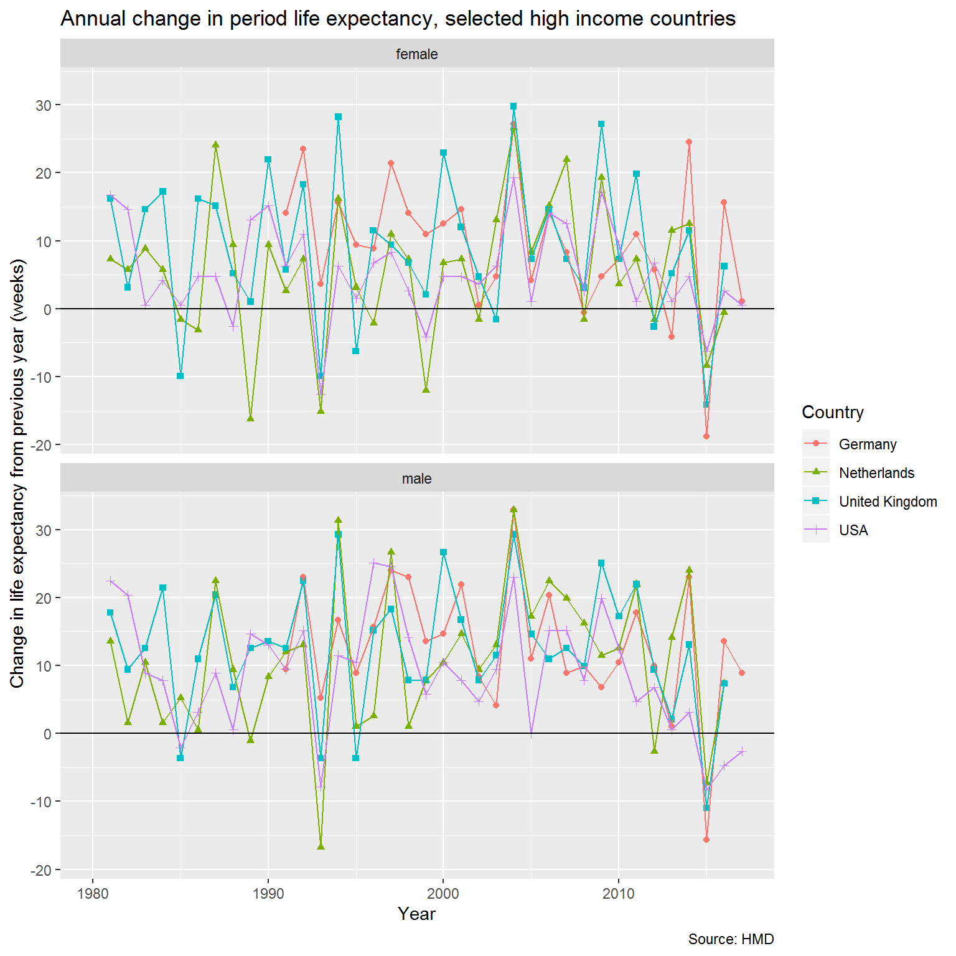

## Change in life expectancy, UK and UK constituent nations

Secondly, we will calculate changes in life expectancy for each UK nation or group of nations, to see whether the slowdown is similar in magnitude and contemporaneous throughout UK populations; this will be supported by performing change-point analysis of annual life expectancy changes for each of these UK populations.

# **2 Annual change rates in life expectancy in the UK as a whole and UK nations or groups of nations + change point analyses**

The previous section used data from the HMD, comparing the UK as a whole against other countries in the HMD. The last year available for the UK in the HMD was 2016. More recent e0e0 estimates are available from the ONS, which also provides estimates disaggregated by country and group of countries within the UK. We will use this data to explore how (dis)similar the trends in life expectancy change have been within different UK nations/groups of nations.

|  |
| --- |
|  |

| **population**  <chr> | **year**  <dbl> | **sex**  <chr> | **e0**  <dbl> |
| --- | --- | --- | --- |
| England | 1980 | female | 76.81 |
| England | 1980 | male | 70.80 |
| England | 1981 | female | 77.11 |
| England | 1981 | male | 71.13 |
| England | 1982 | female | 77.20 |
| England | 1982 | male | 71.29 |
| England | 1983 | female | 77.45 |
| England | 1983 | male | 71.54 |
| England | 1984 | female | 77.79 |
| England | 1984 | male | 71.95 |

**2.2 Analysis**

**2.2.1 Change in life expectancy in UK nations and groups of nations**

**2.2.1.1 Figure of change in life expectancy in UK nations and groups of nations**

Visualise the life expectancy and change in life expectancy for each year

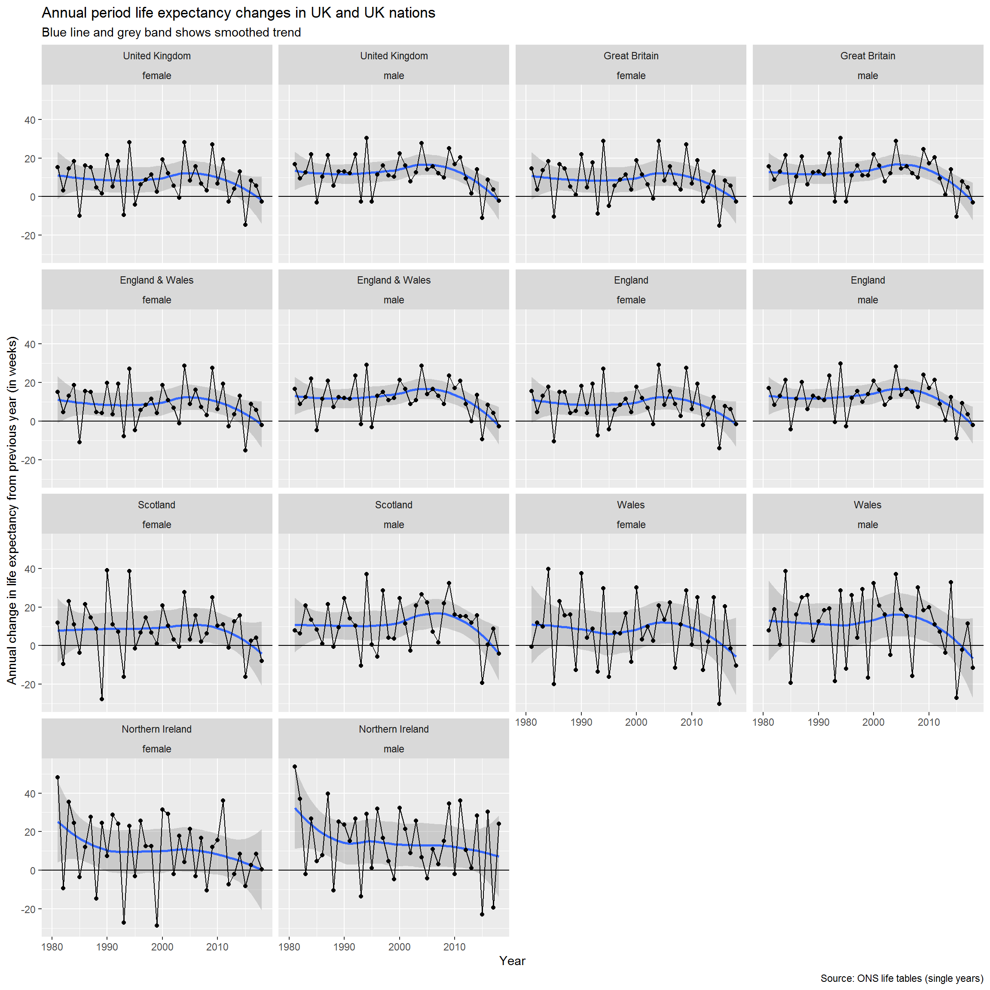

From the above it seems most populations have seen a slowdown in improvement in recent years, and on average relatively stable improvements previously, with the exception of Northern Ireland, which saw a slowdown in improvement in the 1980s. The smaller populations tend to exhibit greater variability in annual rates of change than the larger populations. The extent of oscillation (negative autocorrelation from one year to the next) also appears greater in smaller populations. It is not immediately clear that the breakpoint for the slowdown is the same for all UK populations.

**2.2.2 Average change by decade**

As before, let’s look at the average improvement per decade. This will allow us to compare the UK rates from the ONS against those in the HMD.

|  |
| --- |
|  |

| **population**  <fctr> | **sex**  <chr> | **decade**  <chr> | **mean_ch_e0**  <dbl> |
| --- | --- | --- | --- |
| United Kingdom | female | 1980s | 0.16777778 |
| United Kingdom | female | 1990s | 0.17000000 |
| United Kingdom | female | 2000s | 0.24100000 |
| United Kingdom | female | 2010s | 0.08000000 |
| United Kingdom | male | 1980s | 0.23000000 |
| United Kingdom | male | 1990s | 0.23200000 |
| United Kingdom | male | 2000s | 0.31300000 |
| United Kingdom | male | 2010s | 0.13111111 |
| Great Britain | female | 1980s | 0.16444444 |
| Great Britain | female | 1990s | 0.17100000 |

As expected, the ONS and HMD estimates of mean improvement per decade are closely aligned, usually within two decimal places, though are somewhat lower in the 2010s for ONS than for HMD:

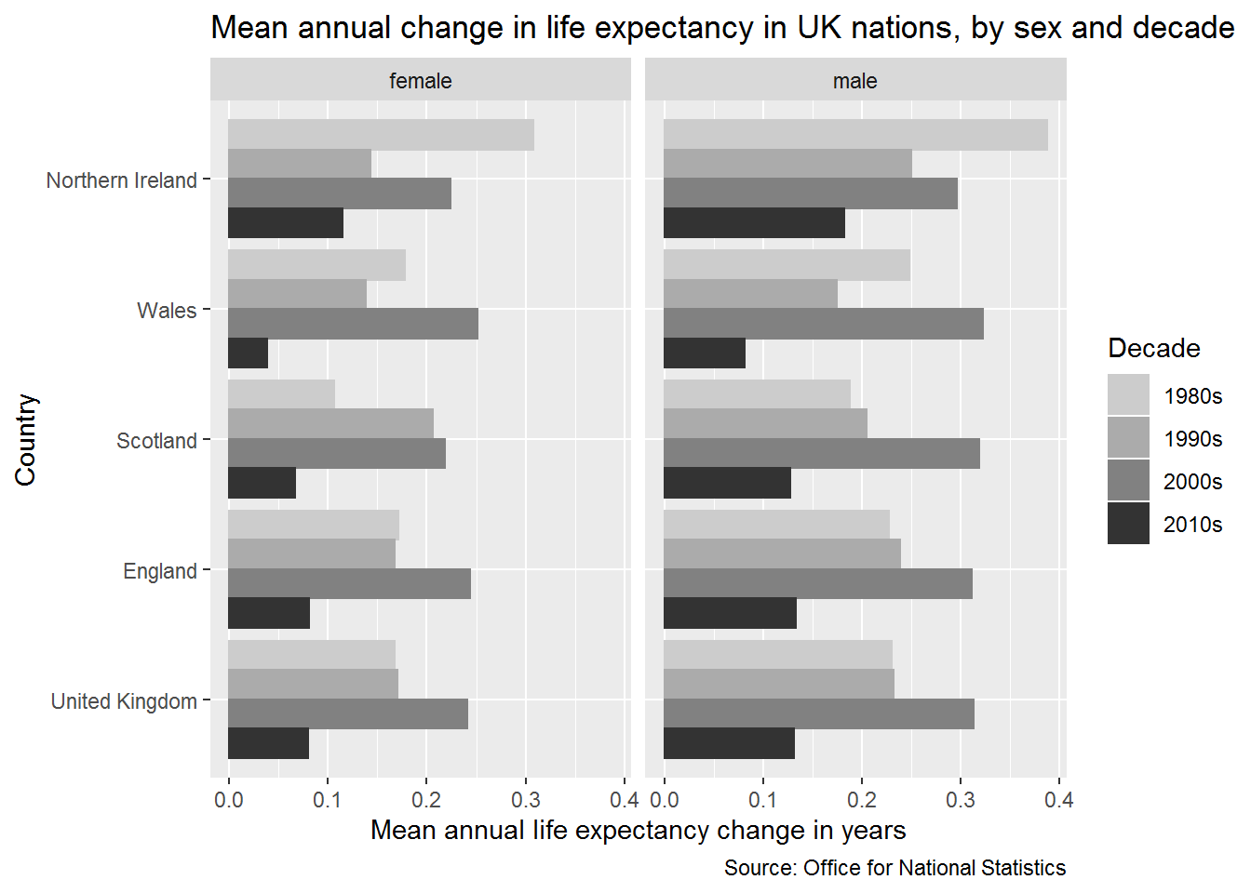

| **sex** | **decade** | **HMD** | **ONS** |
| --- | --- | --- | --- |
| f | 80s | 0.168 | 0.168 |
| f | 90s | 0.168 | 0.170 |
| f | 00s | 0.244 | 0.241 |
| f | 10s | 0.091 | 0.080 |
| m | 80s | 0.229 | 0.230 |
| m | 90s | 0.229 | 0.232 |
| m | 00s | 0.319 | 0.313 |
| m | 10s | 0.164 | 0.131 |

Let’s now present this as a barplot

For each UK nation, the 2000s had exceptionally high rates of improvement. By contrast the 2010s are exceptionally low. Within Northern Ireland, there was an exceptionally high rate of improvement in the 1980s. Rates of improvement in the 2000s have been higher in the 2000s in males than females.

**2.2.3 Change in life expectancy in mutually exclusive UK nations**

**2.2.3.1 Change in life expectancy in mutually exclusive UK nations - faceted**

#### 

#### **2.2.3.2 Change in life expectancy in mutually exclusive UK nations – overlaid**

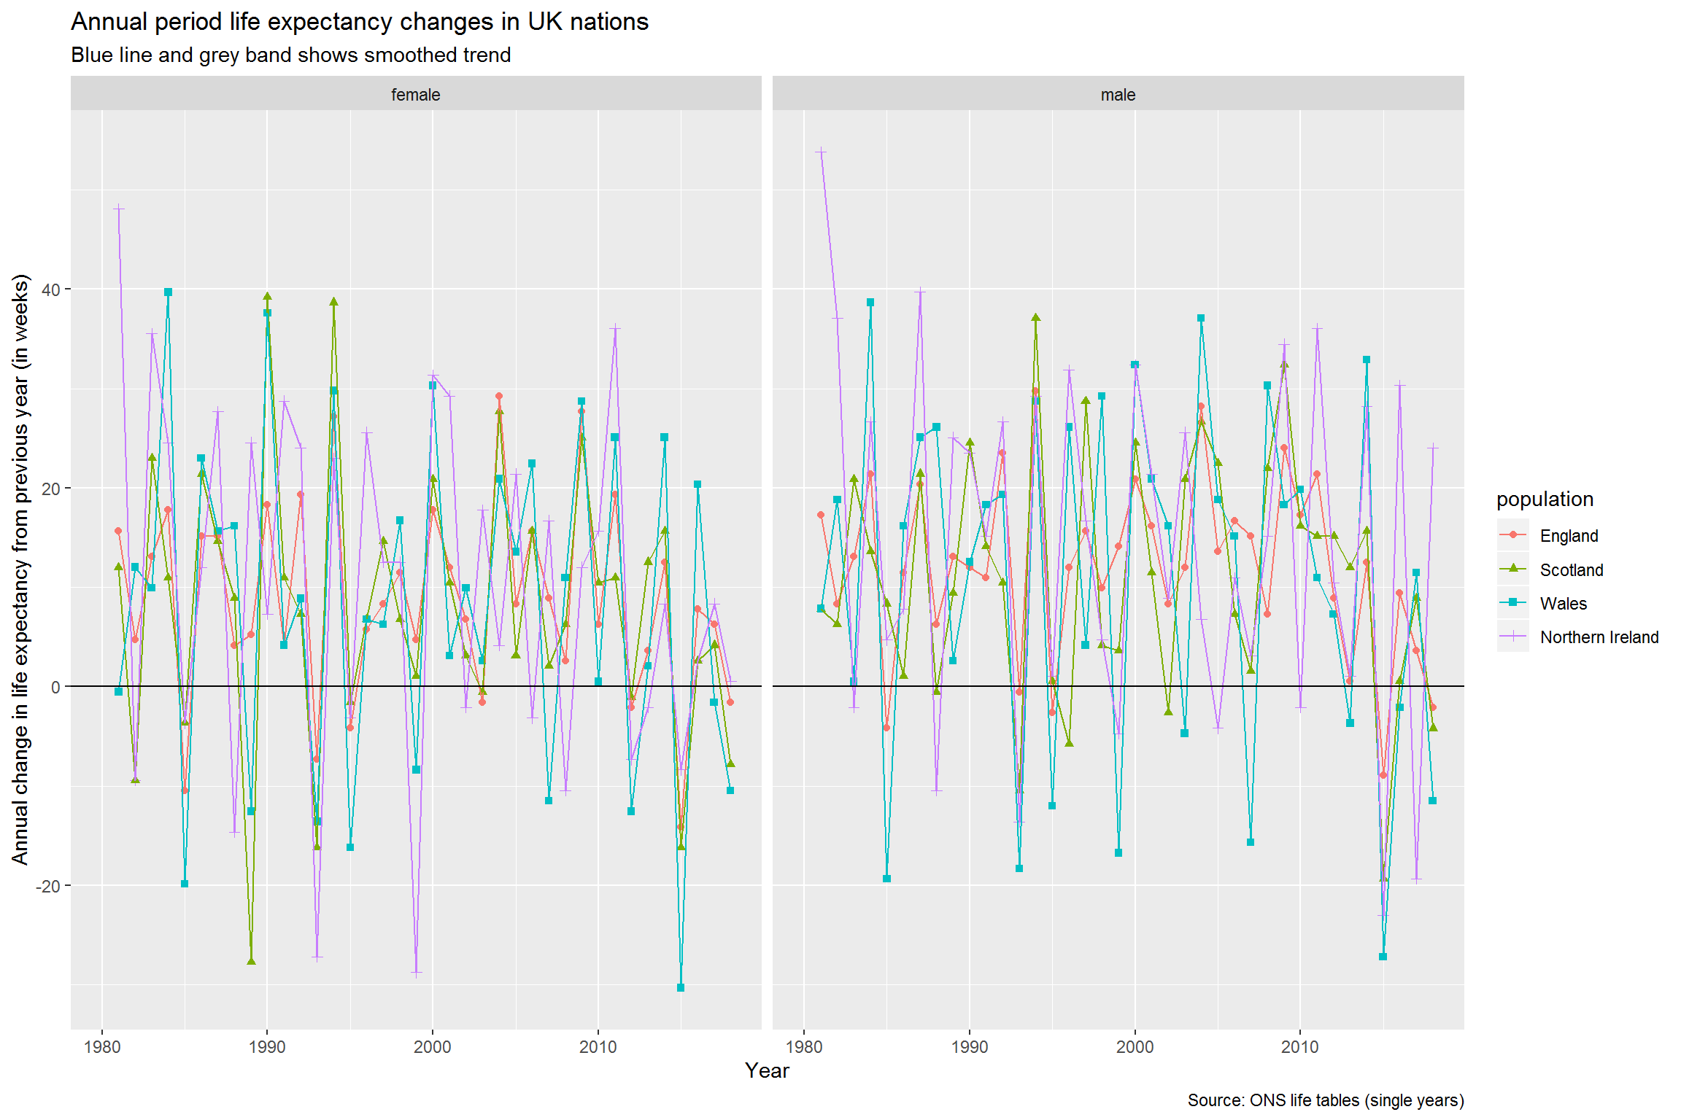

There are clear similarities between the trends in each of the UK nations, again with the exception of Northern Ireland. The trends even seem to correspond in terms of which years are ‘good years’ and which years are ‘bad years’ (i.e. they oscillate in phase with each other). To check this let’s look at the correlation between the trends.

|  |
| --- |
|  |

| **rowname**  <chr> | **England_female**  <dbl> | **England_male**  <dbl> | **Northern Ireland_female**  <dbl> |  |
| --- | --- | --- | --- | --- |
| England_female | *NA* | 0.8948164 | 0.5202739 |  |
| England_male | 0.8948164 | *NA* | 0.5633628 |  |
| Northern Ireland_female | 0.5202739 | 0.5633628 | *NA* |  |
| Northern Ireland_male | 0.4978847 | 0.5355912 | 0.5540548 |  |
| Scotland_female | 0.7748321 | 0.6215946 | 0.3588286 |  |
| Scotland_male | 0.6337257 | 0.6817908 | 0.4110520 |  |
| Wales_female | 0.8082490 | 0.6682959 | 0.3316528 |  |
| Wales_male | 0.6785138 | 0.6435823 | 0.3780715 |  |

8 rows | 1-4 of 9 columns

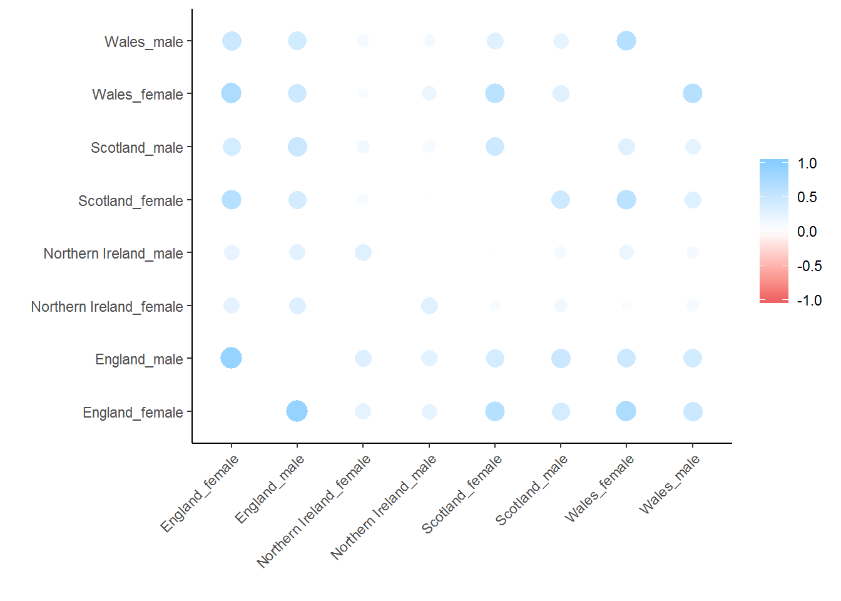

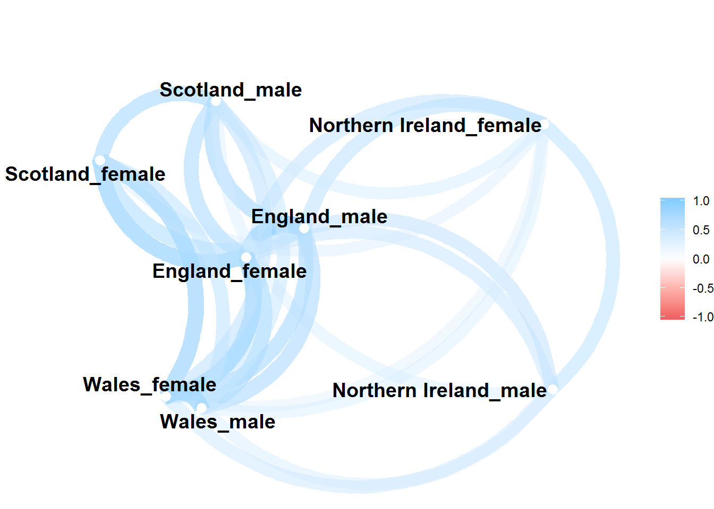

Trends in males and females in England are highly correlated (r = 0.89). The correlation between male and female trends in Wales are also strong (r = 0.77), which is slightly below the correlation between females in England and Wales (r = 0.81). Correlations between males and females in Scotland are slightly weaker (r = 0.67), and the associations between sexes are weakest in Northern Ireland (r = 0.55).

The network plot places series that are more correlated with each other closer together, and less correlated series further from each other. This confirms that males’ and females’ trends are closely correlated to each other in England and Wales, somewhat less so in Scotland, and least in Northern Ireland, where trends between sexes are less correlated with each other than are the correlations between countries elsewhere in the UK.

This suggests that any general trends which apply throughout the UK will apply less strongly in Northern Ireland than elsewhere. This should be considered when looking at the results in the next section, which aims to identify if and when there have been breakpoints in the trends in UK nations.

**2.2.4 Breakpoint analysis**

The following section will perform breakpoint analysis using the segmented package for each UK nation as well as the UK as a whole.

First we look to see if two and three breakpoints can be identified in any of the populations.

In many cases, breakpoints cannot be identified. However this may be if multiple breakpoints are being attempted, but not all can be estimated. We are mainly interested in whether there’s been a single breakpoint, and whether this has been identified consistently in all populations.

To investigate this, let’s explore whether the same single breakpoint can be consistently identified. We can do that by checking whether the choice of random number seed matters.

Note that consecutive random numbers cannot be used, as for some random numbers (4, 5 and 7 in this case) breakpoints cannot be identified.

Let’s pull the 1 breakpoint estimates

* Note: For some reason this currentl doesn’t run. I’m not sure of the reasons so this needs to be fixed at some point.

This shows that 1 breakpoint models can be identified for each population, but 2 and 3 breakpoint models only for some populations. For almost all populations, except Northern Ireland, the breakpoint is identified as around 2009 (so the change from 2009 to 2010)

**2.2.4.1 Breakpoint figure**

The following shows the breakpoints and standard errors.

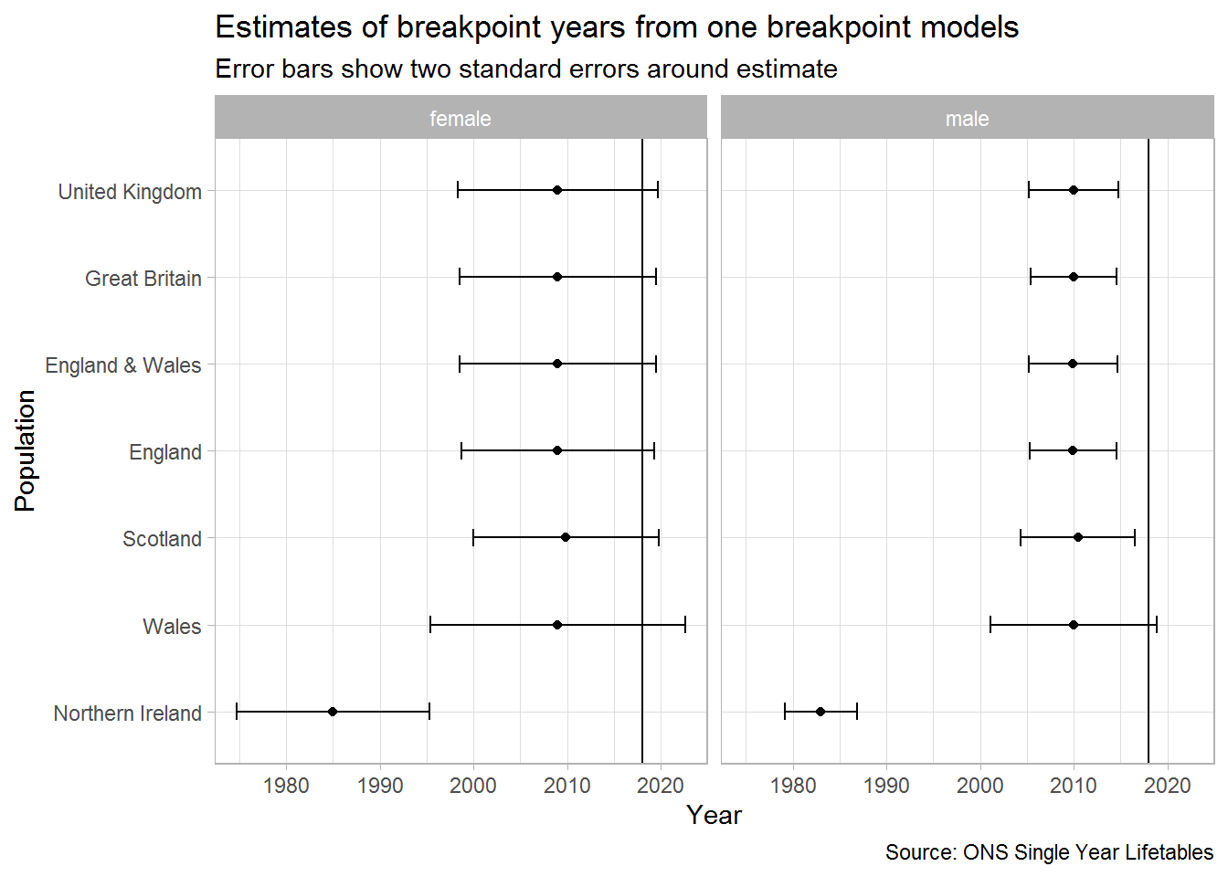

**2.2.4.2 Breakpoint table**

This shows a lot of consistency in estimates of when the breakdown occurred. With the exception of Northern Ireland, we can use 2010 afterwards as ‘post-slowdown’, and the years from 1980 onwards as ‘pre-slowdown’.

| **Population** | **Sex** | **Breakpoint** | **SE** | **Lower CI** | **Upper CI** |
| --- | --- | --- | --- | --- | --- |
| England | female | 2009.00 | 5.15 | 1998.70 | 2019.30 |
| England | male | 2009.93 | 2.34 | 2005.26 | 2014.60 |
| Northern Ireland | female | 1985.00 | 5.13 | 1974.73 | 1995.27 |
| Northern Ireland | male | 1983.00 | 1.92 | 1979.16 | 1986.84 |
| Scotland | female | 2009.87 | 4.95 | 1999.97 | 2019.77 |
| Scotland | male | 2010.45 | 3.05 | 2004.36 | 2016.54 |
| Wales | female | 2009.00 | 6.80 | 1995.40 | 2022.60 |
| Wales | male | 2010.00 | 4.43 | 2001.14 | 2018.86 |
| England & Wales | female | 2009.00 | 5.25 | 1998.49 | 2019.51 |
| England & Wales | male | 2009.92 | 2.35 | 2005.22 | 2014.63 |
| Great Britain | female | 2009.00 | 5.26 | 1998.48 | 2019.52 |
| Great Britain | male | 2009.98 | 2.29 | 2005.41 | 2014.56 |
| United Kingdom | female | 2009.00 | 5.35 | 1998.30 | 2019.70 |
| United Kingdom | male | 2009.95 | 2.39 | 2005.18 | 2014.72 |

#### **2.2.4.3 Breakpoint figure - mutually exclusive UK nations**

The following shows the breakpoints and standard errors.

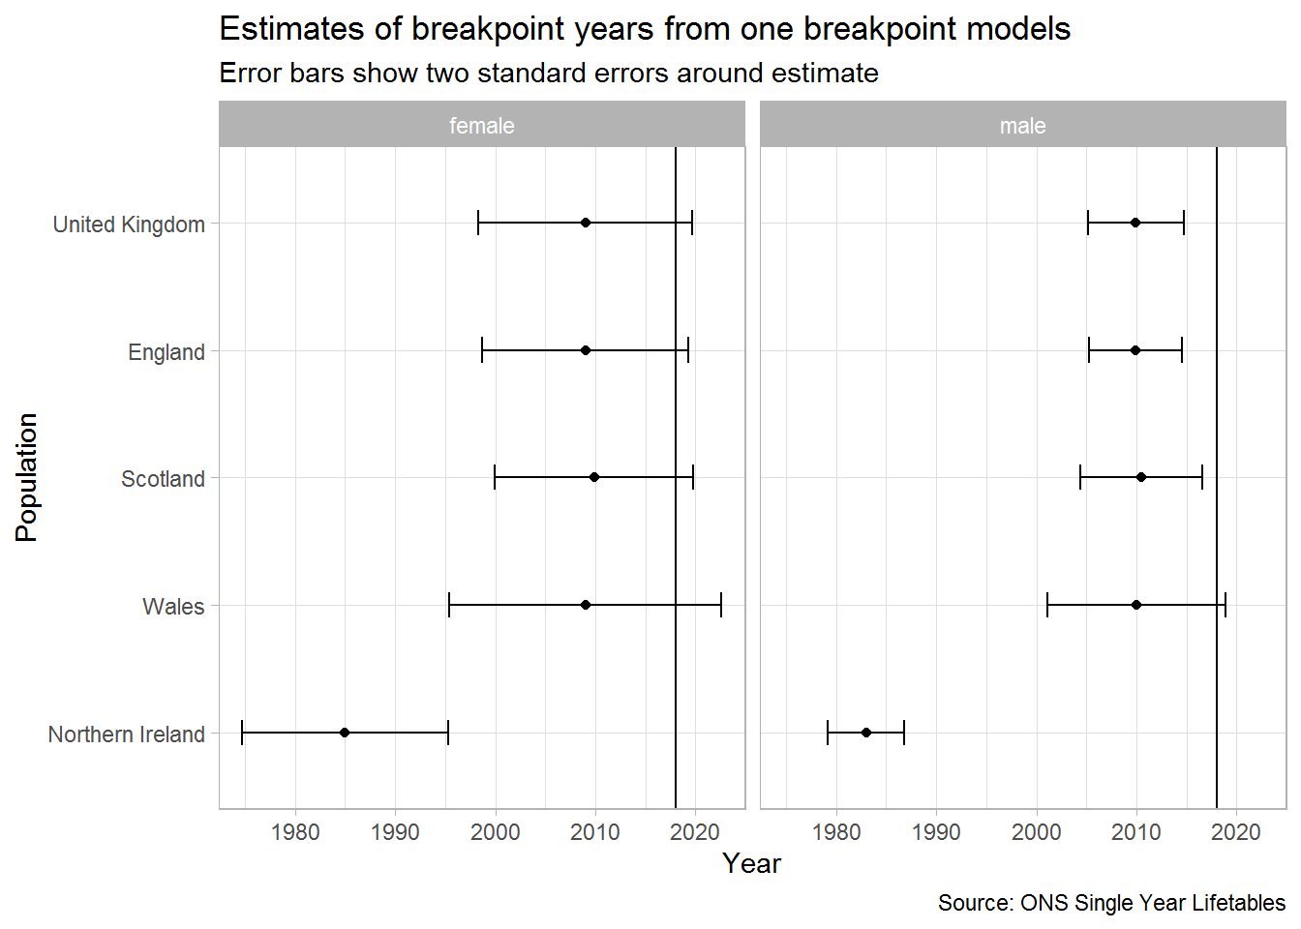

**2.2.4.2 Breakpoint table**

This shows a lot of consistency in estimates of when the breakdown occurred. With the exception of Northern Ireland, we can use 2010 afterwards as ‘post-slowdown’, and the years from 1980 onwards as ‘pre-slowdown’.

| **Population** | **Sex** | **Breakpoint** | **SE** | **Lower CI** | **Upper CI** |
| --- | --- | --- | --- | --- | --- |
| England | female | 2009.00 | 5.15 | 1998.70 | 2019.30 |
| England | male | 2009.93 | 2.34 | 2005.26 | 2014.60 |
| Northern Ireland | female | 1985.00 | 5.13 | 1974.73 | 1995.27 |
| Northern Ireland | male | 1983.00 | 1.92 | 1979.16 | 1986.84 |
| Scotland | female | 2009.87 | 4.95 | 1999.97 | 2019.77 |
| Scotland | male | 2010.45 | 3.05 | 2004.36 | 2016.54 |
| Wales | female | 2009.00 | 6.80 | 1995.40 | 2022.60 |
| Wales | male | 2010.00 | 4.43 | 2001.14 | 2018.86 |
| England & Wales | female | 2009.00 | 5.25 | 1998.49 | 2019.51 |
| England & Wales | male | 2009.92 | 2.35 | 2005.22 | 2014.63 |
| Great Britain | female | 2009.00 | 5.26 | 1998.48 | 2019.52 |
| Great Britain | male | 2009.98 | 2.29 | 2005.41 | 2014.56 |
| United Kingdom | female | 2009.00 | 5.35 | 1998.30 | 2019.70 |
| United Kingdom | male | 2009.95 | 2.39 | 2005.18 | 2014.72 |

**2.2.4.2 Effect of different random number seeds on breakpoint**

Let’s do the same for the five one breakpoint models using different seeds

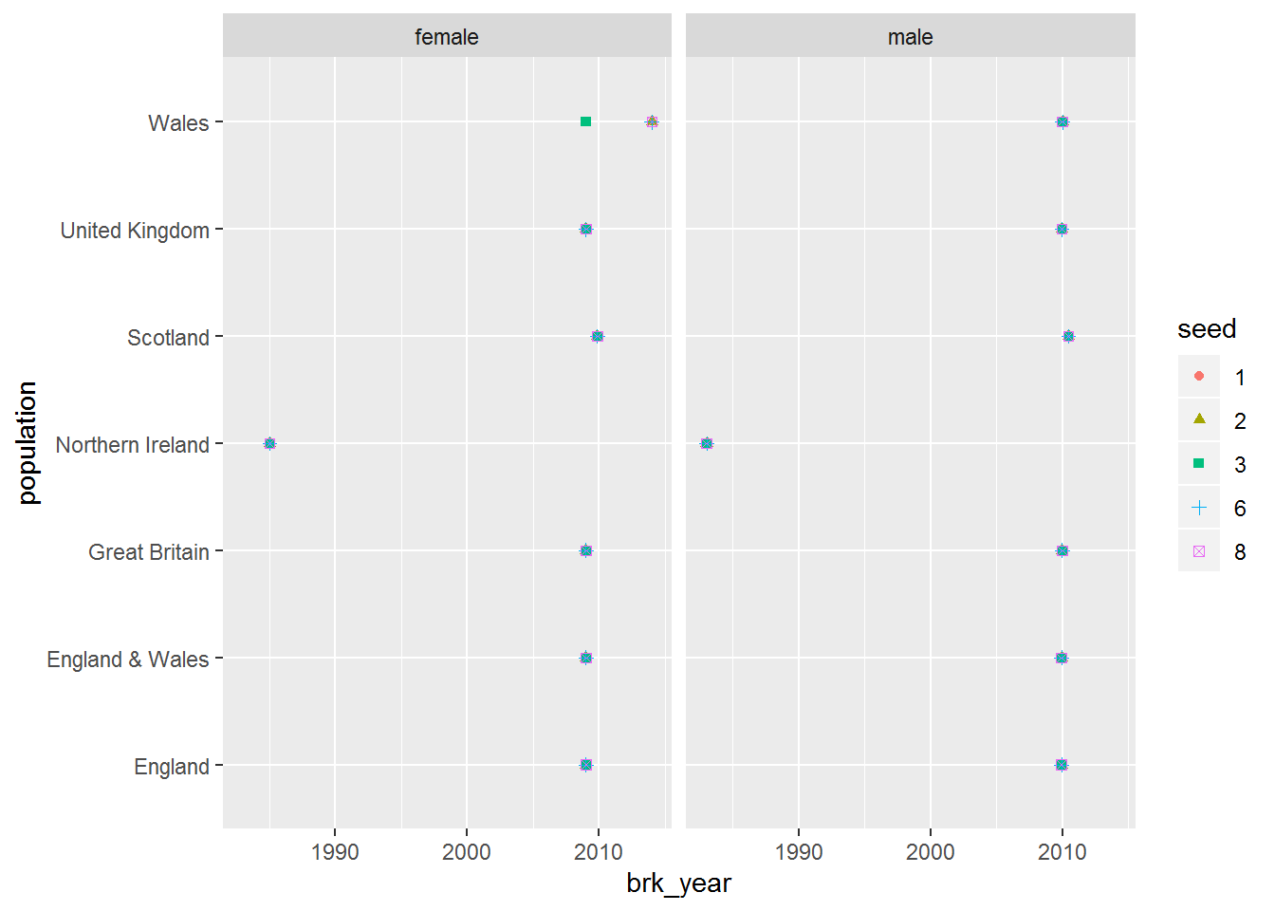

 Break point years, where they can be calculated, are largely identical. They confirm 2010 as a reasonable breakpoint year except for Northern Ireland.

1. ONS life expectancy projections from 2012 onwards, to show how these have been successively downrated with each biennial projection

## ONS UK life expectancy projections since 2012

Thirdly, we will present the ONS life expectancy projections for the UK from 2012 onwards, to show how these projections have been successively downrated with each biennial projection.

## **3 ONS life expectancy projections**

The ONS modifies their estimates of life expectancy every couple of years as part of their population projections exercise. For the last four projections the life expectancy projections have been downgraded. This section will show how projections have changed over time, and how they compare against observed life expectancy.

**3.2 Visualise projections**

**3.2.1 Change in projections**

How do the projections (e0 at birth) change over time between countries?

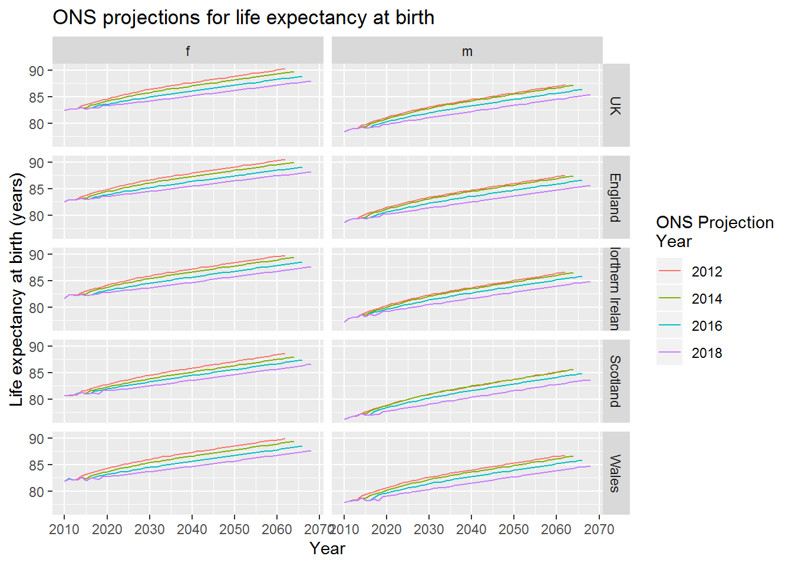

**3.2.2 Change in projections - annual increases**

For each of these projections, what’s the implied expected improvement level?

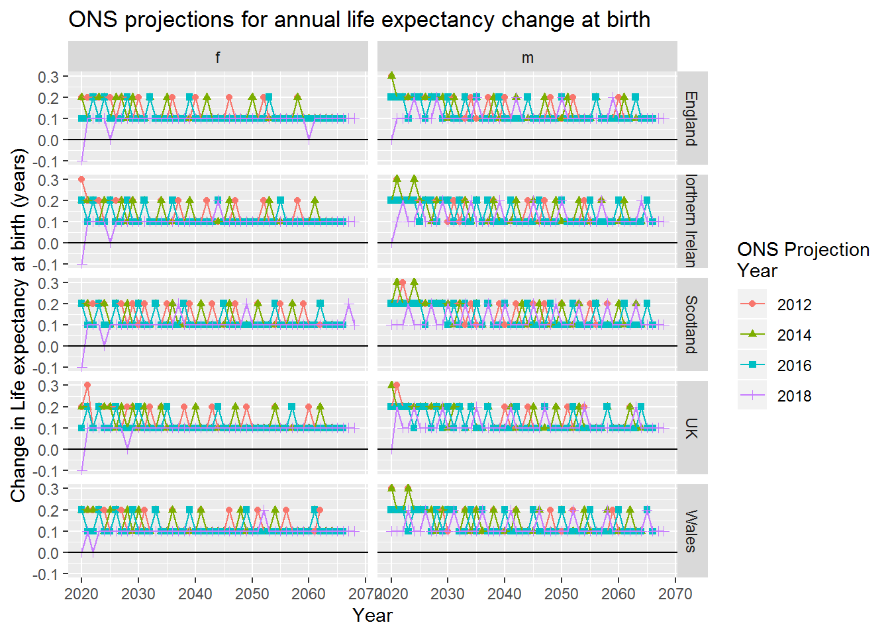

So, the projections involve adding varying numbers of increments of 0.1 life expectancy gain per year. Values within these intervals are created by changing the numbers of years of 0.2, 0.1 and 0.0 gain.

**3.2.3 Projections at all ages**

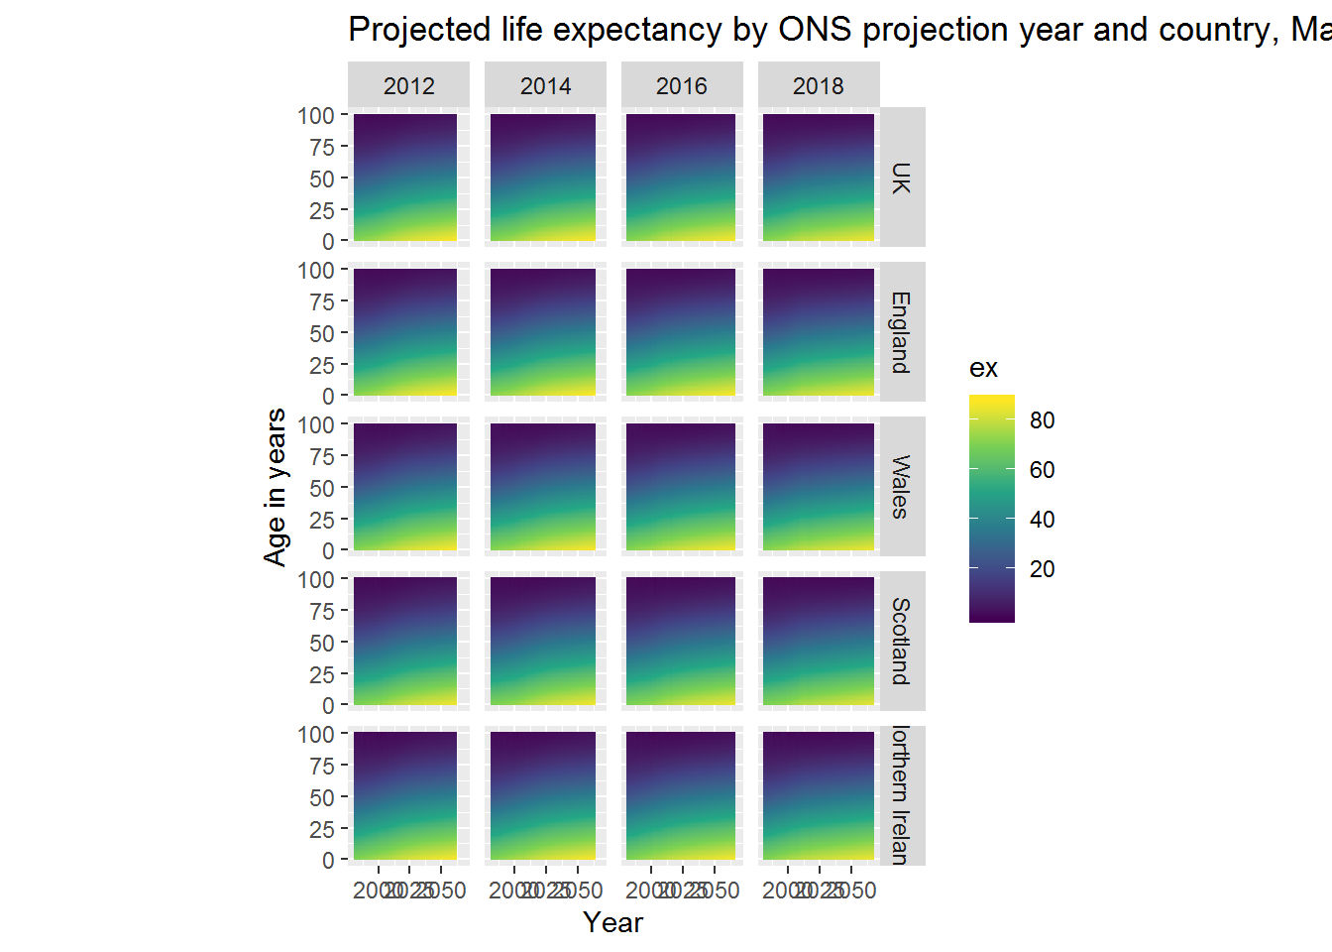

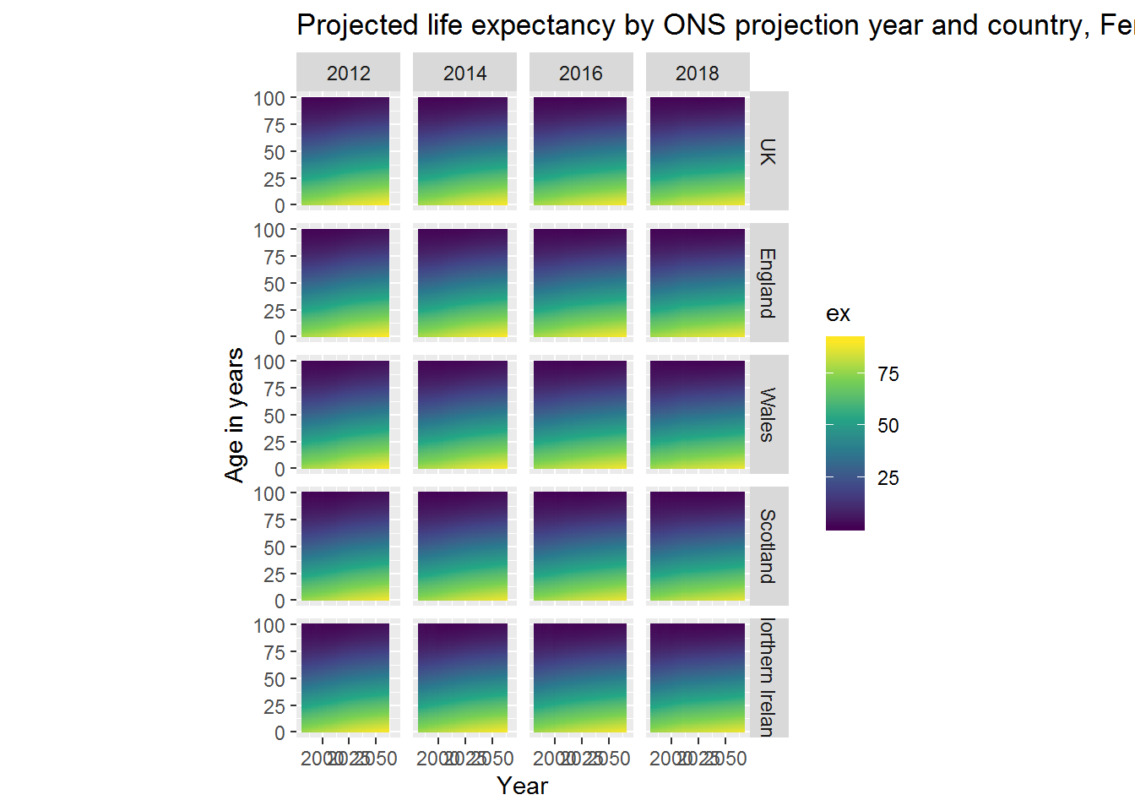

**3.2.4 Change in projections at all ages**

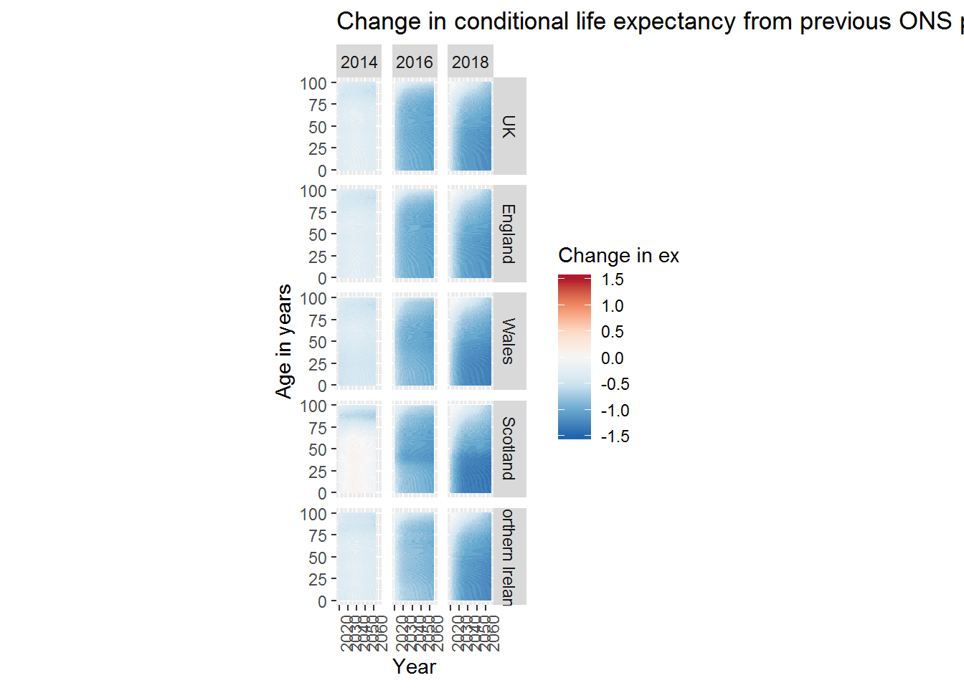

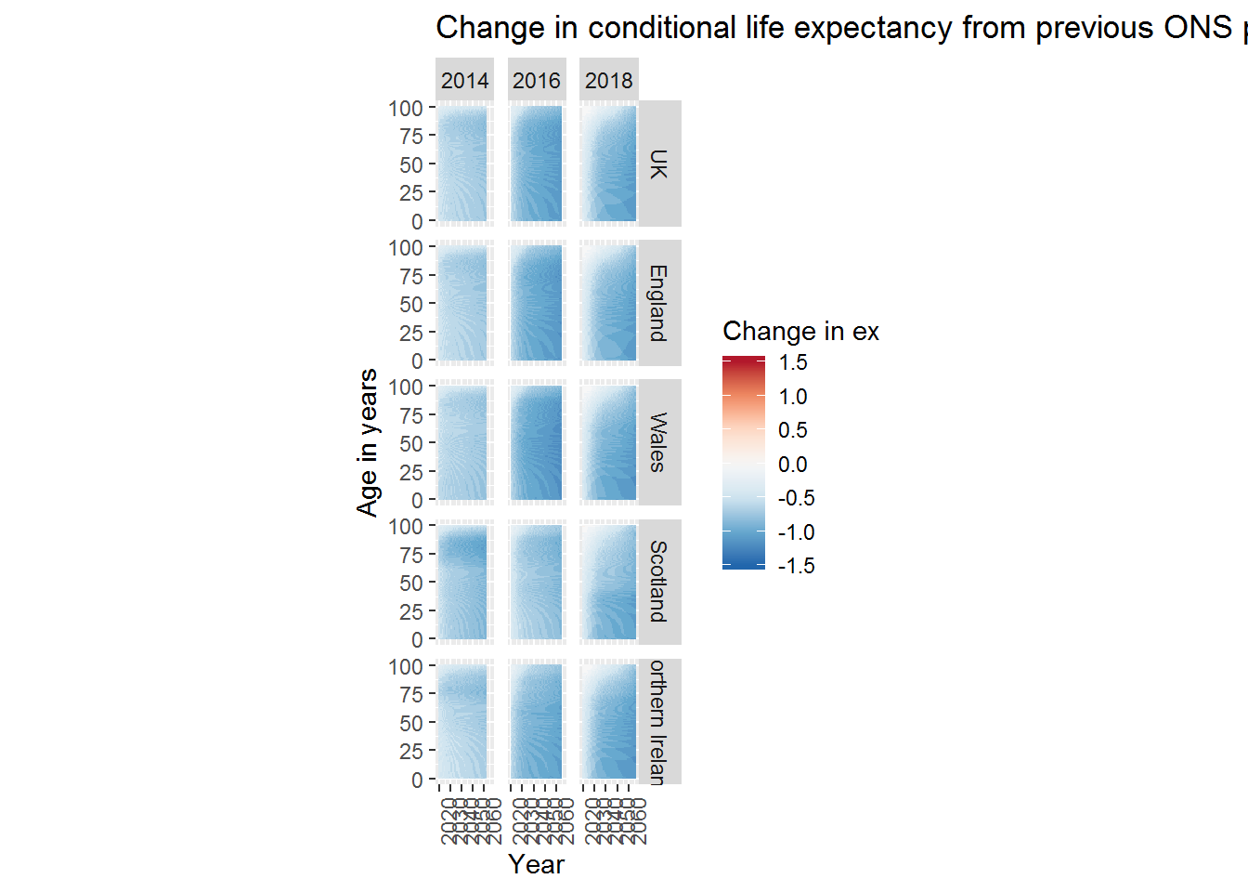

**3.3 Summaries**

**3.3.1 Average projected improvement**

Let’s summarise this:

|  |
| --- |
|  |

| **sex**  <chr> | **country**  <chr> | **proj_year**  <dbl> | **mean_ch_e0**  <dbl> | **sd_ch_e0**  <dbl> |
| --- | --- | --- | --- | --- |
| f | England | 2012 | 0.13488372 | 0.04822428 |
| f | England | 2014 | 0.12666667 | 0.04472136 |
| f | England | 2016 | 0.11276596 | 0.03373181 |
| f | England | 2018 | 0.09183673 | 0.03437983 |
| f | Northern Ireland | 2012 | 0.13720930 | 0.05355574 |
| f | Northern Ireland | 2014 | 0.12888889 | 0.04583678 |
| f | Northern Ireland | 2016 | 0.11702128 | 0.03798826 |
| f | Northern Ireland | 2018 | 0.09591837 | 0.03511400 |
| f | Scotland | 2012 | 0.13953488 | 0.04947118 |
| f | Scotland | 2014 | 0.13111111 | 0.04681794 |

At this point let’s compare the ONS projections against the historic values observed since 1990

| **sex** | **decade** | **HMD** | **ONS** |
| --- | --- | --- | --- |
| f | 80s | 0.168 | 0.168 |
| f | 90s | 0.168 | 0.170 |
| f | 00s | 0.244 | 0.241 |
| f | 10s | 0.091 | 0.080 |
| m | 80s | 0.229 | 0.230 |
| m | 90s | 0.229 | 0.232 |
| m | 00s | 0.319 | 0.313 |
| m | 10s | 0.164 | 0.131 |

| **sex** | **2012** | **2014** | **2016** | **2018** |
| --- | --- | --- | --- | --- |
| f | 0.137 | 0.129 | 0.115 | 0.094 |
| m | 0.148 | 0.147 | 0.134 | 0.114 |

So, the projections have all assumed that the rates of improvement observed in the 2000s are not sustainable in the long term, but have been downrated by around a third from 2012 to 2018 for females, and by around a fifth from 2012 to 2018 for males. Assumed rates of improvement are around 17.5% higher than observed in the 2010s for females, and around 13% higher than observed in the 2010s for males.

To put more simply: the 2012 ONS projection assumed the rate of improvement would be the midpoint between the 1990 and 2010-11 rates, and subsequent projections have tended increasingly towards the post 2010 improvement levels. They have largely been responsive to the new and much slowed life expectancy gains.

The before period used in the Bayes Factor calculations before is 1991 onwards. Let’s identify what the average improvement was over this period.

| **sex** | **mean_ch_e0** | **var_ch_e0** |
| --- | --- | --- |
| female | 0.191 | 0.039 |
| male | 0.276 | 0.026 |

This checks out with what I’ve calculated before. (Phew!)

**3.3.1.1 Average projected improvement - visualised**

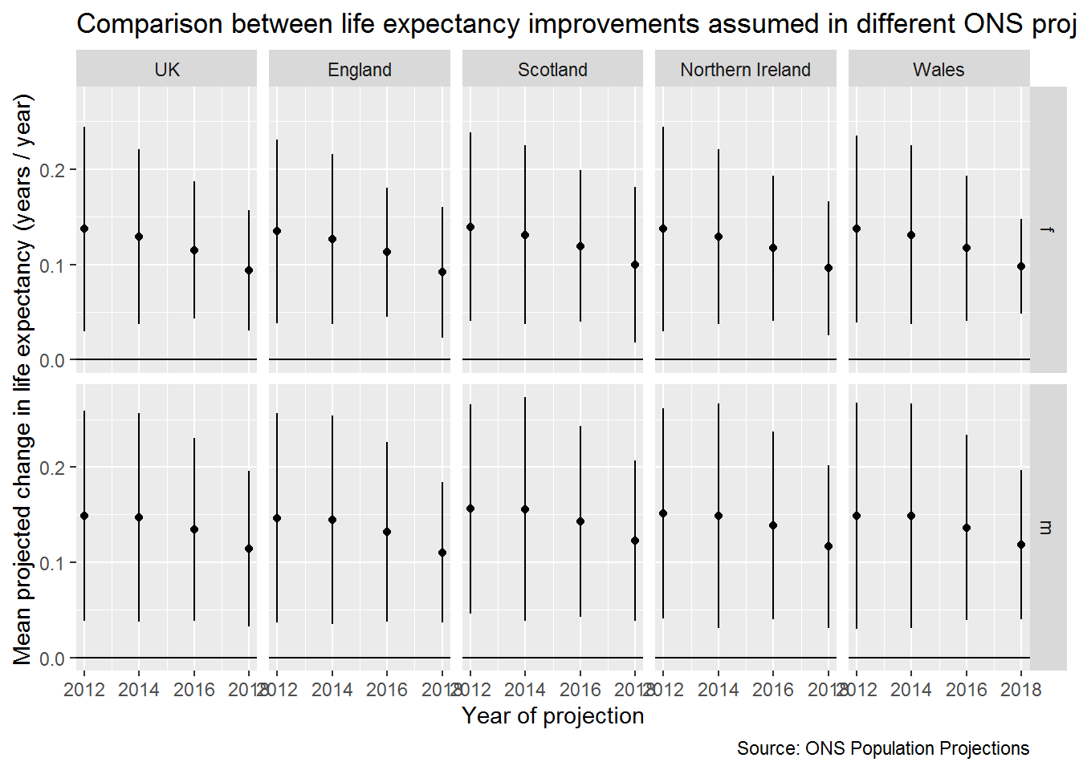

Bayes Factor Maximisation

Fourthly, we will formally quantify the extent of the slowing in life expectancy improvement rates since 2010 by proposing a series of 100 modelled scenarios, each corresponding to a different percentage slowdown from earlier trends, and identifying the slowdown rate that maximises the Bayes Factor (ratio of model likelihoods, as compared with no slowdown) given observed life expectancy.

**4 Bayes Factors**

Bayes Factors for e0e0 changes since 2010 assuming different rates of slowdown expressed as a % of average prior change

**5 Bayes Factors against ONS projections**

1. Average improvement rates for e0e0 implied by each ONS projection, to quantify how optimistic/pessimistic each of the projections has been compared with post 2010 trends

===========

Now, let’s determine the average change (and SD) from 1980 to 2010

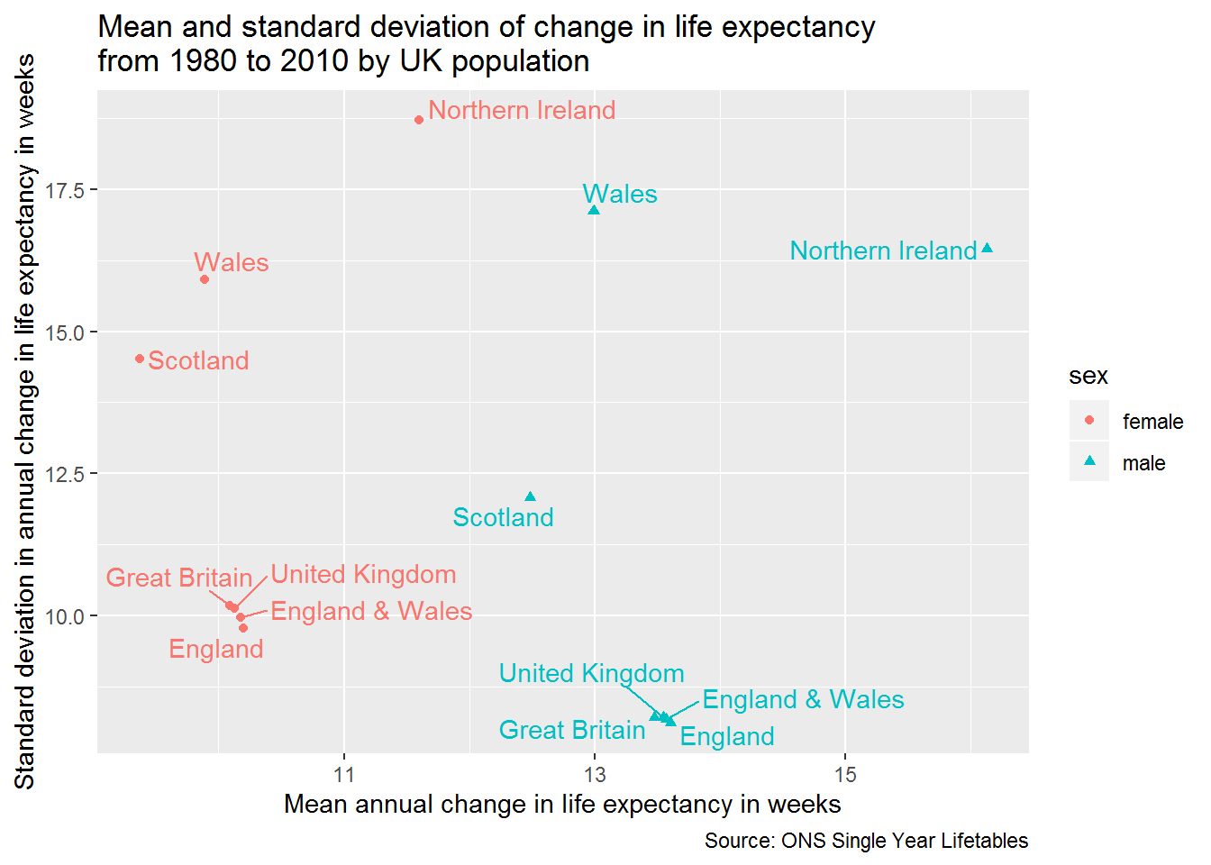

For each of these populations, we can estimate the relative likelihood of observing the observed life expectancies from 2011 onwards under the assumption that each population’s fundamentals of life expectancy improvement had not changed after 2010. This assumption is questionable for Northern Ireland because of its changepoint in the mid 1980s, but will be applied to this population too for consistency with the other populations.

|  |
| --- |
|  |

| **population**  <chr> | **sex**  <chr> | **after_end**  <int> | **perc**  <dbl> | **mu**  <dbl> | **ll**  <dbl> | **bayes_factor**  <dbl> | **period**  <chr> |
| --- | --- | --- | --- | --- | --- | --- | --- |
| England | female | 2011 | 1.00 | 0.194500 | 0.7173006 | 1.0000000 | 2011-11 |
| England | female | 2011 | 0.99 | 0.192555 | 0.7172876 | 0.9999870 | 2011-11 |
| England | female | 2011 | 0.98 | 0.190610 | 0.7172745 | 0.9999739 | 2011-11 |
| England | female | 2011 | 0.97 | 0.188665 | 0.7172612 | 0.9999606 | 2011-11 |
| England | female | 2011 | 0.96 | 0.186720 | 0.7172478 | 0.9999472 | 2011-11 |
| England | female | 2011 | 0.95 | 0.184775 | 0.7172342 | 0.9999336 | 2011-11 |
| England | female | 2011 | 0.94 | 0.182830 | 0.7172205 | 0.9999199 | 2011-11 |
| England | female | 2011 | 0.93 | 0.180885 | 0.7172066 | 0.9999060 | 2011-11 |
| England | female | 2011 | 0.92 | 0.178940 | 0.7171926 | 0.9998920 | 2011-11 |
| England | female | 2011 | 0.91 | 0.176995 | 0.7171785 | 0.9998779 | 2011-11 |

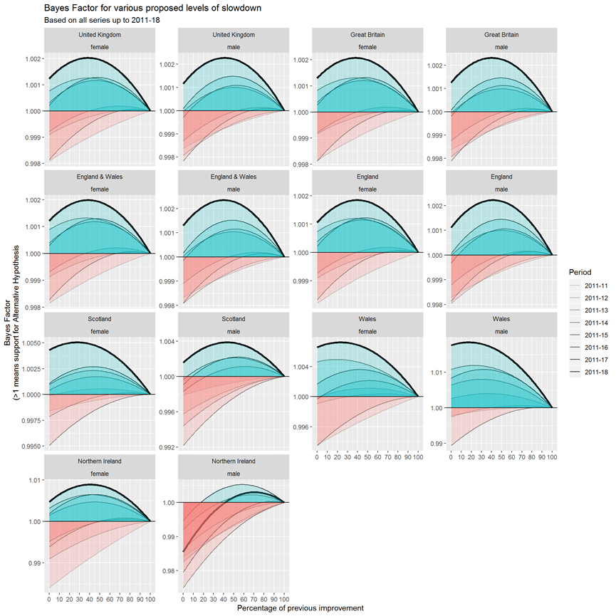

For all populations except males in Northern Ireland, the addition of the 2018 single year life expectancy data led to sizeable increases in the empirical support for the belief that there has been a slowdown in life expectancy after 2010; this is seen by noting how much higher the bold line, which incorporates the 2018 data, is than the fainter lines representing cumulative data based on shorter series of observations. For most of these populations, the peak of the bold line is to the left of peaks based on earlier series, meaning not only did the 2018 observations increase the strength of evidence supporting belief in a slowdown in life expectancy improvements, but also suggested more severe magnitudes of slowdown than the series excluding this most recent observation had indicated. For the UK as a whole, the addition of the life expectancy data for 2018 suggested an overall slowdown of around 60% was most likely, compared with a most likely magnitude of slowdown of around 50% based on data up to 2017. For each of these populations, what does the Bayes Factor maximise at?

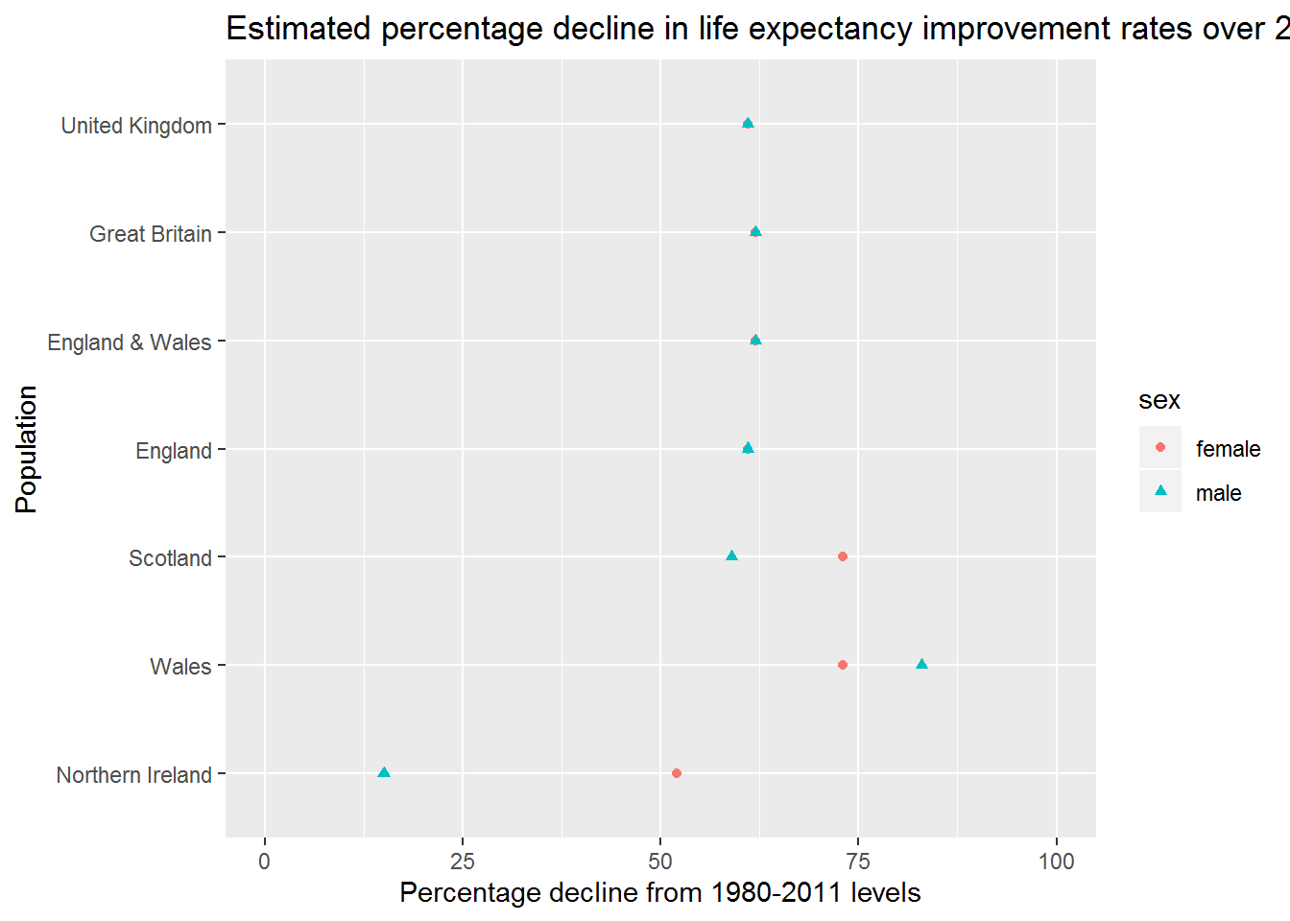

And as a table

|  |
| --- |
|  |

| **population**  <fctr> | **sex**  <chr> | **perc**  <dbl> | **bayes_factor**  <dbl> |
| --- | --- | --- | --- |
| England | female | 61 | 1.002120 |
| England | male | 61 | 1.002958 |
| England & Wales | female | 62 | 1.002173 |
| England & Wales | male | 62 | 1.003081 |
| Great Britain | female | 62 | 1.002221 |
| Great Britain | male | 62 | 1.003173 |
| Northern Ireland | female | 52 | 1.004581 |
| Northern Ireland | male | 15 | 1.000435 |
| Scotland | female | 73 | 1.003834 |
| Scotland | male | 59 | 1.005845 |

In the UK as a whole, it is most likely that life expectancy improvement rates have slowed down by 62% for females, and 59% for males. This is made up of a 60% (females) and 59% (males) slowdown in England, a 72% (females) and 56% (males) slowdown in Scotland, a 59% (females) and 29% (males) slowdown in Northern Ireland, and an estimated 77% (females) and 83% (males) slowdown in Wales. With the exception of males in Northern Ireland, rates of slowdown are therefore similar across UK nations, and generally slightly more severe for females than males.

Some important points:

* This approach means that the process of updating beliefs about the extent and evidence for a slowdown in life expectancy gains can be made formally rather than informally.
* The Bayes Factor schedules can be recalculated whenever a new data release becomes available. This means that updated schedules can be produced within minutes of the release of official statistics. The commitment to do this each each new release, and to publish updated estimates of support for slowdown, should be made before such data are released.
* The tendency within UK populations has been for the rate of slowdown to be increasing over time, rather than to shift suddenly from one rate to another. If this continues then the proposed slowdown percentage that maximises the bayes factor will continue to shift further to the left with additional years’ data, and could be maximised at a negative value (i.e. declining life expectancy rather than slowing improvement) if this tendency continues.

## Comparison between Bayes Factor and ONS projections

Finally, we will estimate the Bayes Factors implied by each of the average improvement rates implied by each of the recent ONS mortality projections, discussing how optimistic or pessimistic each of these scenarios seems to be, and how the Bayes Factor strategy can be applied to more openly update our beliefs about the persistence and extent of a life expectancy slowdown in the UK as and when the 2019 period life expectancy estimate becomes available.

Let’s now compare the values that maximise the Bayes factor against the ONS population projections:

| **Year** | **BF- female** | **BF- male** | **ONS- female** | **ONS- male** |
| --- | --- | --- | --- | --- |
| 2011-2012 | 0.161 | 0.276 | 0.137 | 0.148 |
| 2011-2014 | 0.163 | 0.218 | 0.129 | 0.147 |
| 2011-2016 | 0.088 | 0.138 | 0.115 | 0.134 |
| 2011-2018 | 0.075 | 0.108 | 0.094 | 0.114 |

So, up to 2014, the ONS was projecting a slower improvement rates than 2011-12 alone would suggest. For the 2016 and 2018 projections, the rates were slightly higher than the Bayes Factor alone would suggest, especially for females. Now, the remaining analysis (possibly the only remaining analysis) is to express the UK’s recent improvement rates and ONS projections as a % of the mean improvement from 1980 to 2010.

Code

|  |
| --- |
|  |

| **sex**  <chr> | **mean_ch_e0**  <dbl> | **var_ch_e0**  <dbl> |
| --- | --- | --- |
| female | 0.1974194 | 0.03615978 |
| male | 0.2654839 | 0.02369226 |

So, by 2012 the ONS was projecting future improvmeent rates that were around 30% lower (1 - 0.137 / 0.197) than long-term average improvement rates for females, and around 44% lower than long-term trends (1 - 0.148 / 0.265) for males. By contrast the Bayes Factor approach alone would predict slowdowns of around 18% for females, and gains of around 4% for males.

By 2014 the ONS was projecting slowdowns of around 35% for females, and 44% for males. This contrasts with Bayes Factor estimates of around a

| **Year** | **BF_female** | **BF_male** | **ONS_female** | **ONS_male** |
| --- | --- | --- | --- | --- |
| 2011-12 | 0.816 | 1.040 | 0.694 | 0.557 |
| 2011-14 | 0.826 | 0.821 | 0.653 | 0.554 |
| 2011-16 | 0.446 | 0.520 | 0.583 | 0.505 |
| 2011-18 | 0.380 | 0.407 | 0.476 | 0.429 |

And as a graph

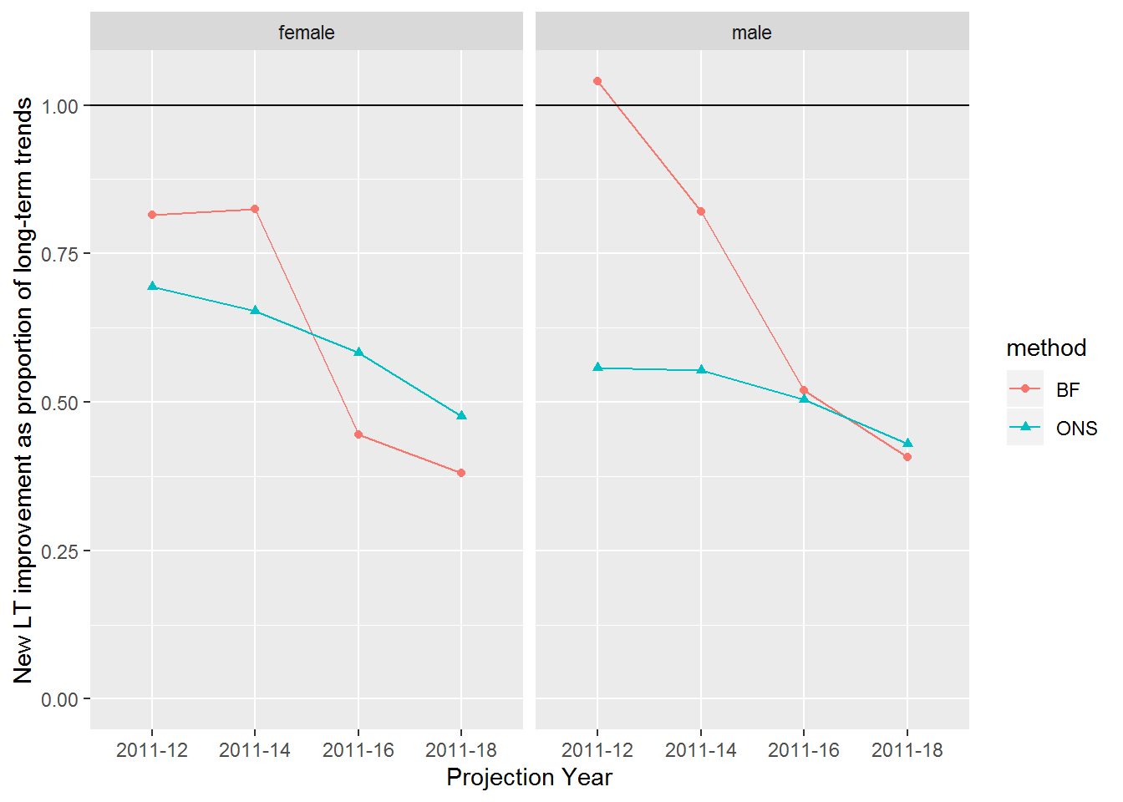

So, it appears the ONS, and the experts who advised them, believed that the long-term improvement trends were unsustainable from 2011 onwards, and projected trends that were slower than the average improvement rates seen between 1980 and 2011. However, each successive biennial update has projected a slower rate of improvement than the previous projection. The Bayes Factor approach, with the accumulated data from 2011 to 2018, suggests the ONS projections are largely in line with recent data for males, but may still be underestimating the extent of the stalling in life expectancy gains for females.

An advantage of the Bayes Factor approach is that it is trivial to update it every year, taking only a minute or so to rerun with an additional year’s worth of data. This means that as soon as new data becomes available, it can be used to update our beliefs about long-term trends, and the extent of the deterioration from long-term trends if the accumulated recent data is considered representive of how long-term trends are likely to progress.

Discussion

Scrapbook

# Appendices

## Location of ONS Mortality Data

**3.1 Data**

For Scotland, the data for the projections are made available at [this location](https://www.ons.gov.uk/peoplepopulationandcommunity/birthsdeathsandmarriages/lifeexpectancies/datasets/expectationoflifeprincipalprojectionscotland) on the ONS website:

The specific projections are available at the following locations:

* [2018 projection for Scotland](https://www.ons.gov.uk/file?uri=%2fpeoplepopulationandcommunity%2fbirthsdeathsandmarriages%2flifeexpectancies%2fdatasets%2fexpectationoflifeprincipalprojectionscotland%2f2018based/scppp18ex.xls)
* [2016 projection for Scotland](https://www.ons.gov.uk/file?uri=%2fpeoplepopulationandcommunity%2fbirthsdeathsandmarriages%2flifeexpectancies%2fdatasets%2fexpectationoflifeprincipalprojectionscotland%2f2016based/wscoprincipal16.xls)
* [2014 projection for Scotland](https://www.ons.gov.uk/file?uri=%2fpeoplepopulationandcommunity%2fbirthsdeathsandmarriages%2flifeexpectancies%2fdatasets%2fexpectationoflifeprincipalprojectionscotland%2f2014based/wscoprincipal14.xls)
* [2012 projection for Scotland](https://www.ons.gov.uk/file?uri=%2fpeoplepopulationandcommunity%2fbirthsdeathsandmarriages%2flifeexpectancies%2fdatasets%2fexpectationoflifeprincipalprojectionscotland%2f2012based/wscoprincipal12exr.xls)

For England, the projections are [available here](https://www.ons.gov.uk/peoplepopulationandcommunity/birthsdeathsandmarriages/lifeexpectancies/datasets/expectationoflifeprincipalprojectionengland).

* [2018 projection for England](https://www.ons.gov.uk/file?uri=%2fpeoplepopulationandcommunity%2fbirthsdeathsandmarriages%2flifeexpectancies%2fdatasets%2fexpectationoflifeprincipalprojectionengland%2f2018based/engppp18ex.xls)
* [2016 projection for England](https://www.ons.gov.uk/file?uri=%2fpeoplepopulationandcommunity%2fbirthsdeathsandmarriages%2flifeexpectancies%2fdatasets%2fexpectationoflifeprincipalprojectionengland%2f2016based/wengprincipal16.xls)
* [2014 projection for England](https://www.ons.gov.uk/file?uri=%2fpeoplepopulationandcommunity%2fbirthsdeathsandmarriages%2flifeexpectancies%2fdatasets%2fexpectationoflifeprincipalprojectionengland%2f2014based/wengprincipal14.xls)
* [2012 projection for England](https://www.ons.gov.uk/file?uri=%2fpeoplepopulationandcommunity%2fbirthsdeathsandmarriages%2flifeexpectancies%2fdatasets%2fexpectationoflifeprincipalprojectionengland%2f2012based/wengprincipal12.xls)

For Wales, the projections are [available here](https://www.ons.gov.uk/peoplepopulationandcommunity/birthsdeathsandmarriages/lifeexpectancies/datasets/expectationoflifeprincipalprojectionwales).

* [2018 projection for Wales](https://www.ons.gov.uk/file?uri=%2fpeoplepopulationandcommunity%2fbirthsdeathsandmarriages%2flifeexpectancies%2fdatasets%2fexpectationoflifeprincipalprojectionwales%2f2018based/walppp18ex.xls)
* [2016 projection for Wales](https://www.ons.gov.uk/file?uri=%2fpeoplepopulationandcommunity%2fbirthsdeathsandmarriages%2flifeexpectancies%2fdatasets%2fexpectationoflifeprincipalprojectionwales%2f2016based/wwalprincipal16.xls)
* [2014 projection for Wales](https://www.ons.gov.uk/file?uri=%2fpeoplepopulationandcommunity%2fbirthsdeathsandmarriages%2flifeexpectancies%2fdatasets%2fexpectationoflifeprincipalprojectionwales%2f2014based/wwalprincipal14.xls)
* [2012 projection for Wales](https://www.ons.gov.uk/file?uri=%2fpeoplepopulationandcommunity%2fbirthsdeathsandmarriages%2flifeexpectancies%2fdatasets%2fexpectationoflifeprincipalprojectionwales%2f2012based/wwalprincipal12.xls)

For Northern Ireland, the projections are [available here](https://www.ons.gov.uk/peoplepopulationandcommunity/birthsdeathsandmarriages/lifeexpectancies/datasets/expectationoflifeprincipalprojectionnorthernireland)

* [2018 projection for Northern Ireland](https://www.ons.gov.uk/file?uri=%2fpeoplepopulationandcommunity%2fbirthsdeathsandmarriages%2flifeexpectancies%2fdatasets%2fexpectationoflifeprincipalprojectionnorthernireland%2f2018based/nippp18ex.xls)
* [2016 projection for Northern Ireland](https://www.ons.gov.uk/file?uri=%2fpeoplepopulationandcommunity%2fbirthsdeathsandmarriages%2flifeexpectancies%2fdatasets%2fexpectationoflifeprincipalprojectionnorthernireland%2f2016based/wniprincipal16.xls)
* [2014 projection for Northern Ireland](https://www.ons.gov.uk/file?uri=%2fpeoplepopulationandcommunity%2fbirthsdeathsandmarriages%2flifeexpectancies%2fdatasets%2fexpectationoflifeprincipalprojectionnorthernireland%2f2014based/wniprincipal14.xls)
* [2012 projection for Northern Ireland](https://www.ons.gov.uk/file?uri=%2fpeoplepopulationandcommunity%2fbirthsdeathsandmarriages%2flifeexpectancies%2fdatasets%2fexpectationoflifeprincipalprojectionnorthernireland%2f2012based/wniprincipal12.xls)

The for United Kingdom, the projections are [available here](https://www.ons.gov.uk/peoplepopulationandcommunity/birthsdeathsandmarriages/lifeexpectancies/datasets/expectationoflifeprincipalprojectionunitedkingdom)

* [2018 projection for United Kingdom](https://www.ons.gov.uk/file?uri=%2fpeoplepopulationandcommunity%2fbirthsdeathsandmarriages%2flifeexpectancies%2fdatasets%2fexpectationoflifeprincipalprojectionunitedkingdom%2f2018based/ukppp18ex.xls)
* [2016 projection for United Kingdom](https://www.ons.gov.uk/file?uri=%2fpeoplepopulationandcommunity%2fbirthsdeathsandmarriages%2flifeexpectancies%2fdatasets%2fexpectationoflifeprincipalprojectionunitedkingdom%2f2016based/wukprincipal16.xls)
* [2014 projection for United Kingdom](https://www.ons.gov.uk/file?uri=%2fpeoplepopulationandcommunity%2fbirthsdeathsandmarriages%2flifeexpectancies%2fdatasets%2fexpectationoflifeprincipalprojectionunitedkingdom%2f2014based/wukprincipal14.xls)
* [2012 projection for United Kingdom](https://www.ons.gov.uk/file?uri=%2fpeoplepopulationandcommunity%2fbirthsdeathsandmarriages%2flifeexpectancies%2fdatasets%2fexpectationoflifeprincipalprojectionunitedkingdom%2f2012based/wukprincipal12exr.xls)

**3.1.1 Pull all data from ONS website**

For England, the projections are [available here](https://www.ons.gov.uk/peoplepopulationandcommunity/birthsdeathsandmarriages/lifeexpectancies/datasets/expectationoflifeprincipalprojectionengland).

* [2018 projection for England](https://www.ons.gov.uk/file?uri=%2fpeoplepopulationandcommunity%2fbirthsdeathsandmarriages%2flifeexpectancies%2fdatasets%2fexpectationoflifeprincipalprojectionengland%2f2018based/engppp18ex.xls)
* [2016 projection for England](https://www.ons.gov.uk/file?uri=%2fpeoplepopulationandcommunity%2fbirthsdeathsandmarriages%2flifeexpectancies%2fdatasets%2fexpectationoflifeprincipalprojectionengland%2f2016based/wengprincipal16.xls)
* [2014 projection for England](https://www.ons.gov.uk/file?uri=%2fpeoplepopulationandcommunity%2fbirthsdeathsandmarriages%2flifeexpectancies%2fdatasets%2fexpectationoflifeprincipalprojectionengland%2f2014based/wengprincipal14.xls)
* [2012 projection for England](https://www.ons.gov.uk/file?uri=%2fpeoplepopulationandcommunity%2fbirthsdeathsandmarriages%2flifeexpectancies%2fdatasets%2fexpectationoflifeprincipalprojectionengland%2f2012based/wengprincipal12.xls)

For Wales, the projections are [available here](https://www.ons.gov.uk/peoplepopulationandcommunity/birthsdeathsandmarriages/lifeexpectancies/datasets/expectationoflifeprincipalprojectionwales).

* [2018 projection for Wales](https://www.ons.gov.uk/file?uri=%2fpeoplepopulationandcommunity%2fbirthsdeathsandmarriages%2flifeexpectancies%2fdatasets%2fexpectationoflifeprincipalprojectionwales%2f2018based/walppp18ex.xls)
* [2016 projection for Wales](https://www.ons.gov.uk/file?uri=%2fpeoplepopulationandcommunity%2fbirthsdeathsandmarriages%2flifeexpectancies%2fdatasets%2fexpectationoflifeprincipalprojectionwales%2f2016based/wwalprincipal16.xls)
* [2014 projection for Wales](https://www.ons.gov.uk/file?uri=%2fpeoplepopulationandcommunity%2fbirthsdeathsandmarriages%2flifeexpectancies%2fdatasets%2fexpectationoflifeprincipalprojectionwales%2f2014based/wwalprincipal14.xls)
* [2012 projection for Wales](https://www.ons.gov.uk/file?uri=%2fpeoplepopulationandcommunity%2fbirthsdeathsandmarriages%2flifeexpectancies%2fdatasets%2fexpectationoflifeprincipalprojectionwales%2f2012based/wwalprincipal12.xls)

For Northern Ireland, the projections are [available here](https://www.ons.gov.uk/peoplepopulationandcommunity/birthsdeathsandmarriages/lifeexpectancies/datasets/expectationoflifeprincipalprojectionnorthernireland)

* [2018 projection for Northern Ireland](https://www.ons.gov.uk/file?uri=%2fpeoplepopulationandcommunity%2fbirthsdeathsandmarriages%2flifeexpectancies%2fdatasets%2fexpectationoflifeprincipalprojectionnorthernireland%2f2018based/nippp18ex.xls)
* [2016 projection for Northern Ireland](https://www.ons.gov.uk/file?uri=%2fpeoplepopulationandcommunity%2fbirthsdeathsandmarriages%2flifeexpectancies%2fdatasets%2fexpectationoflifeprincipalprojectionnorthernireland%2f2016based/wniprincipal16.xls)
* [2014 projection for Northern Ireland](https://www.ons.gov.uk/file?uri=%2fpeoplepopulationandcommunity%2fbirthsdeathsandmarriages%2flifeexpectancies%2fdatasets%2fexpectationoflifeprincipalprojectionnorthernireland%2f2014based/wniprincipal14.xls)
* [2012 projection for Northern Ireland](https://www.ons.gov.uk/file?uri=%2fpeoplepopulationandcommunity%2fbirthsdeathsandmarriages%2flifeexpectancies%2fdatasets%2fexpectationoflifeprincipalprojectionnorthernireland%2f2012based/wniprincipal12.xls)

For Scotland, the data for the projections are made available at [this location](https://www.ons.gov.uk/peoplepopulationandcommunity/birthsdeathsandmarriages/lifeexpectancies/datasets/expectationoflifeprincipalprojectionscotland) on the ONS website:

The specific projections are available at the following locations:

* [2018 projection for Scotland](https://www.ons.gov.uk/file?uri=%2fpeoplepopulationandcommunity%2fbirthsdeathsandmarriages%2flifeexpectancies%2fdatasets%2fexpectationoflifeprincipalprojectionscotland%2f2018based/scppp18ex.xls)
* [2016 projection for Scotland](https://www.ons.gov.uk/file?uri=%2fpeoplepopulationandcommunity%2fbirthsdeathsandmarriages%2flifeexpectancies%2fdatasets%2fexpectationoflifeprincipalprojectionscotland%2f2016based/wscoprincipal16.xls)
* [2014 projection for Scotland](https://www.ons.gov.uk/file?uri=%2fpeoplepopulationandcommunity%2fbirthsdeathsandmarriages%2flifeexpectancies%2fdatasets%2fexpectationoflifeprincipalprojectionscotland%2f2014based/wscoprincipal14.xls)
* [2012 projection for Scotland](https://www.ons.gov.uk/file?uri=%2fpeoplepopulationandcommunity%2fbirthsdeathsandmarriages%2flifeexpectancies%2fdatasets%2fexpectationoflifeprincipalprojectionscotland%2f2012based/wscoprincipal12exr.xls)

## Technical description of Bayes Factor model

**Technical appendix**

**Likelihood and Log Likelihood of the Normal Distribution**

For computational reasons it is more common to calculate the log likelihood of a function rather than the likelihood itself. Defining X={x1,x2,...,xn}X={x1,x2,...,xn} as a series of nn observations, the Log Likelihood of the Normal Distribution is as follows:

logL(μ,σ2|X={x1,x2,...,xn})=−n2log(2π)−nlog(σ)−12σ2∑i=1n(xi−μ)2logL(μ,σ2|X={x1,x2,...,xn})=−n2log(2π)−nlog(σ)−12σ2∑i=1n(xi−μ)2

This is implemented as a function in R as follows:

get_ll <- **function**(x, mu, sig_sq){

sig <- sqrt(sig_sq)

n <- length(x)

- n * log(sig) - (n/2) * log(2 * pi) - (1 / 2 * sig_sq) * sum((x - mu)^2)

}

The Bayes Factor is defined as ratio of Likelihoods of two models. In the general case, if g(θ)g(θ) refers to a model with parameters θθ, and θnullθnull and θaltθalt to two different candidate parameters, then the Bayes Factor is

L(g(θalt)|X)L(g(θnull)|X)L(g(θalt)|X)L(g(θnull)|X)

Note that the alternative and null model specifications both contain a number of parameters in the Log likelihood that are identical. This includes n2log(2π)n2log(2π) and nlog(σ)nlog(σ) (because we are not concerned about testing proposed difference in the variance before and after). This means Bayes Factor could be calculated without including these parameters. However, they have been included for completeness.

# Bibliography

1. ONS. National Population Projections Accuracy Report [Internet]. ONS; 2016 Feb [cited 2020 Jan 7]. Available from: https://www.ons.gov.uk/peoplepopulationandcommunity/populationandmigration/populationprojections/methodologies/nationalpopulationprojectionsaccuracyreport

2. Lee RD, Carter LR. Modeling and forecasting U.S. mortality. J Am Stat Assoc. 1992 Sep;87(419):659–671.

3. Bijak J, Bryant J. Bayesian demography 250 years after Bayes. Popul Stud (NY). 2016 Feb 23;70(1):1–19.

4. King G. Demographic Forecasting. 2008;

5. Renshaw AE, Haberman S. A cohort-based extension to the Lee–Carter model for mortality reduction factors. Insurance: Mathematics and Economics. 2006 Jun;38(3):556–570.

6. Willets R. THE COHORT EFFECT : INSIGHTS AND EXPLANATIONS. Willets Consulting Limited; 2003 p. 1–38.

7. Kermack WO, McKendrick AG, McKinlay PL. Death-rates in Great Britain and Sweden. Some general regularities and their significance. Int J Epidemiol. 2001 Aug;30(4):678–683.

8. Minton J, Vanderbloemen L, Dorling D. Visualizing Europe’s demographic scars with coplots and contour plots. Int J Epidemiol. 2013 Aug;42(4):1164–1176.

9. Almond D. Is the 1918 Influenxa Pandemic Over? Long-Term Effects of In Utero Influenza Exposure in the Post-1940 U.S. Population. Journal of Political Economy2. 2006;114(4):672–712.

10. Willets RC, Gallop AP, Leandro PA, Lu JLC, Macdonald AS, Miller KA, et al. Longevity in the 21st century. Br Actuar J. 2004 Oct 1;10(4):685–832.

11. Pascariu MD, Lenart A, Canudas-Romo V. The maximum entropy mortality model: forecasting mortality using statistical moments. Scand Actuar J. 2019 Mar 29;1–25.

12. White KM. Longevity Advances in High-Income Countries, 1955-96. Popul Dev Rev. 2002 Mar;28(1):59–76.

13. Christensen K, Doblhammer G, Rau R, Vaupel JW. Ageing populations: the challenges ahead. Lancet. 2009 Oct 3;374(9696):1196–1208.

14. Pascariu MD, Canudas-Romo V, Vaupel JW. The double-gap life expectancy forecasting model. Insurance: Mathematics and Economics. 2018 Jan;78:339–350.

15. Torri T, Vaupel JW. Forecasting life expectancy in an international context. Int J Forecast. 2012 Apr;28(2):519–531.

16. Box GEP, Jenkins GM, Reinsel GC, Ljung GM. Time Series Analysis: Forecasting And Control (wiley Series In Probability And Statistics). 5th ed. Hoboken, New Jersey: Wiley; 2015.

17. Hiam L, Dorling D. Rise in mortality in England and Wales in first seven weeks of 2018. BMJ. 2018 Mar 14;360:k1090.

18. Hiam L, Dorling D, McKee M. The cuts and poor health: when and how can we say that one thing causes another? J R Soc Med. 2018 Jun;111(6):199–202.

19. Hiam L, Harrison D, McKee M, Dorling D. Why is life expectancy in England and Wales “stalling”? J Epidemiol Community Health. 2018 Feb 20;72(5):404–408.

20. Hiam L, Dorling D, Harrison D, McKee M. What caused the spike in mortality in England and Wales in January 2015? J R Soc Med. 2017 Apr;110(4):131–137.

21. Hiam L, Dorling D, McKee M. Rise in mortality-when will the government take note? BMJ. 2018 Jun 25;361:k2747.

22. Fenton L, Minton J, Ramsay J, Kaye-Bardgett M, Fischbacher C, Wyper GMA, et al. Recent adverse mortality trends in Scotland: comparison with other high-income countries. BMJ Open. 2019 Oct 31;9(10):e029936.

23. Green MA, Dorling D, Minton J, Pickett KE. Could the rise in mortality rates since 2015 be explained by changes in the number of delayed discharges of NHS patients? J Epidemiol Community Health. 2017 Nov;71(11):1068–1071.

24. Green M, Dorling D, Minton J. The Geography of a rapid rise in elderly mortality in England and Wales, 2014-15. Health Place. 2017 Feb 12;44:77–85.

25. Lambie-Mumford H, Green MA. Austerity, welfare reform and the rising use of food banks by children in England and Wales. Area. 2017 Sep;49(3):273–279.

26. Stuckler D, Basu S. The Body Economic: Eight experiments in economic recovery, from Iceland to Greece. London: Penguin; 2013.

27. Karanikolos M, Mladovsky P, Cylus J, Thomson S, Basu S, Stuckler D, et al. Financial crisis, austerity, and health in Europe. Lancet. 2013 Apr 13;381(9874):1323–1331.

28. McKee M, Karanikolos M, Belcher P, Stuckler D. Austerity: a failed experiment on the people of Europe. Clin Med. 2012 Aug;12(4):346–350.

29. Raleigh V. Trends in life expectancy in EU and other OECD countries: Why are improvements slowing? 2019 Feb.

30. Public Health England. Recent trends in mortality in England: review and data packs - GOV.UK. 2018.

31. Murphy M, Luy M, Torrisi O. Stalling of mortality in the United Kingdom and Europe: an analytical review of the evidence [Internet]. LSE; 2019 Nov [cited 2019 Dec 10]. Report No.: 11-19. Available from: http://www.lse.ac.uk/social-policy/Assets/Documents/PDF/working-paper-series/11-19-Mike-Murphy.pdf

32. Marshall L, Finch D, Cairncross L, Bibby J. Mortality and life expectancy trends in the UK: stalling progress. Health Foundation; 2019 Nov.

33. Raleigh VS. Stalling life expectancy in the UK. BMJ. 2018 Sep 27;362:k4050.